II Methodology of the Study

II.1 Factors influencing methodology of the study.

In his lecture on Climate Risk & Vulnerability, Prof T. Jayaraman who is a member of the negotiating Indian team at the Conference of Parties (COP) has opined that while the naive rationale of a vulnerability study would be to determine the differing degrees of vulnerability, one must question the usefulness of being able to do higher levels of quantification. He says that the important reason for studying vulnerability is to provide the basis for intervention, to find out that what needs to be done, who needs more help/assistance and where States, NGOs, and others should focus.

Prof. Jayaraman emphasizes the difference between risk and vulnerability. The entire population risks the various negative effects; some more, some less according to locational difference, but there is a specific section in every location which is unable to withstand the shock without suffering long-term or irreversible loss of well being. He says, coping is an insufficient concept, as it does not probe the long term or irreversible loss of well being.

Speaking at the National Consultation of the All India Peoples’ Science Forum in Mumbai in July 2001, Prof Jayaraman, who is also, Professor at Centre for Science, Technology and Society, School of Habitat Studies, Tata Institute of Social Sciences, Mumbai said that such studies should help us decide the kind of funding, financial assistance required by the most vulnerable.

A vulnerability study should premise itself on and take into consideration the following assumptions:
- A good index should discriminate well – depending on vulnerability.
- There will be no universality in solutions as these would vary according to agro-climatic, ecological, geophysical features.
- There are a large number of variables that determine vulnerability. This along with differentiation across groups will result in non-standard interpretation. Thus rather than look for uniformity of variables, it may be fruitful to arrive at socio-politico-technical decisions.
Thus this study revolves around those who live near drains, sewage, who are susceptible to floods, landslides, whose houses provide less protection for their family and possessions.

In terms of coping it looks at those who are least capable to cope with impacts on health, injury, death, those who are not able to take short term measures like moving family, belongings, money, utensils, beddings etc just before the flood or disaster hits, and those who are unable to deal with loss of property or income.

Many of the devastating impacts occur without even being recognized as climate change related. It is also in these areas that transformation action, economic, social and environment action is most needed. Thus this study focuses on these elements, and is basically anecdotal in nature, rather than quantitative.

II.2 The Process of the study

This study focuses on vulnerability of the marginalized in an urban setting.

To begin with an advisory group was formed mainly consisting of people from civil society and NGOs working with such marginalized communities, and academicians who have been engaged with social and civic issues. Prof. T.G.Sitharam (Chairman, CiSTUP, IISc), Dr. H.S.Sudhira (Researcher, Gubbi Labs), Rohan D'Souza (Ph.D fellow, NIAS), Dr. Bidisha Nandy (Post-Doc fellow, IISc), Dr. Harini Nagendra (Adjunct Fellow, ATREE & Asia Research Co-ordinator, Indiana University) are among the advisors. Wilma Rodrigues (SAAHAS), Vinay Baindur (Independent Researcher), Arul Selva (Slum Jagatthu), Prema Manthesh (Ragpickers Education & Development Scheme-REDS) were consulted during the study.

At the first meeting of the advisory committee, it was decided that since the purpose of the study is to inform intervention particularly by civil society, the study should be conducted in those areas where NGOs of different kinds are working, so that the benefits of study can inform immediate and proximate action.

The CSOs/local representatives identified to gain access to potential locations for the study included Isaac Amruthraj, activist, REDS, CIEDS, IYCN. After an initial survey of the areas recommended by local CSOs, a comparison chart of all the areas surveyed was prepared to identify the best locations for the study. Comparison chart included the demographics, location, infrastructural amenities, general living conditions within the slums, usage of resources and a preliminary characterization of the coping strategies encountered in each slum.

It was also decided to choose three types of slum settings, a) an old slum naturally formed by early urbanization, b) a rehabilitation or artificially created settlement and c) a peri-urban settlement, which is now urbanized.

It was decided that in view of the purpose of the study, the nature of the issue, and the time framework, the study should be based on intensive interaction with a small group and should centre itself on informing us about the understanding of and response to those areas and indicators of vulnerability that are being discussed at the macro level, and give us insights into its micro aspects, and ground level perceptions. It was therefore decided to do structured interviews based on a preset questionnaire one at the household level and another at the neighbourhood level. Further in order to have some kind of relative reference to peoples interpretations, perceptions and assessment of each of the parameters it was decided to put some measurable quantities or determinable qualities of assets, amenities and impacts.

The questionnaires were prepared with inputs and guidance from Dr. Sudhira. This questionnaire is designed to elicit information on the socio-economic and demographic characteristics, access to essential civic amenities, climatic changes and to some current issues, experiences and coping strategies.

The parameters and indicators which have bearing on vulnerability in general and climate change were identified as individual’s personal background – migratory status, usage and management of natural resources (water and energy), the infrastructural deficits as well as strengths. Perceptions of the community with respect to local environmental changes and the reasons attributed to the changes. In addition, the broad themes to be explored in the study include accessibility and consumption of water, sanitation facilities, solid waste management, energy sources, transportation, public and civic amenities, educational amenities, health care facilities and general health trends of the respondents, livelihood challenges posed due to these observed climatic changes.

The two questionnaires were pre-tested for clarity and concepts by interviewing three households from Parappana Agrahara. One staff member with two observers conducted the interviews. This was followed by detailed discussion at CED, among the researchers, and reactions sought from the advisory committee, by circulating the responses as well as at a meeting on April 11, 2011.

The local representatives from each area –Mr. Manjunath of Parappana Agrahara, Mr. Luvies of EWS Quarters and Mr. Pandurang from KS Garden then helped us identify the persons to be interviewed.

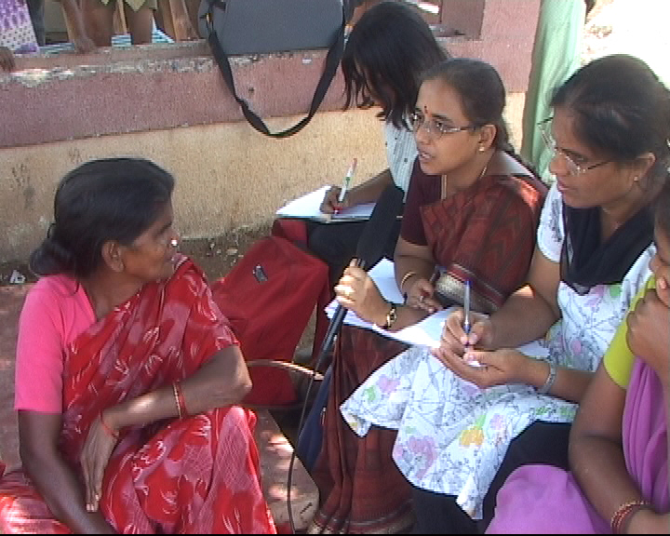

The household level questionnaires were administered by detailed interviews with key members of the household. CED staff members themselves conducted the interviews, an essential feature of the study, which enabled individual level discussion on various episodes and grey interpretations of responses. One to one interviews conducted with the family members by the team in the case of administering the family questionnaires. 56 families in KS Garden, 54 in EWS Quarters and 43 in Parappana Agrahara were surveyed. Attention was paid to developing a strong interpersonal relation with the respondents to enable them to talk freely and without reservations and thus help in the data gathering process. These interactions formed the basis of many individual stories that we have presented within the report.

The neighbourhood survey included observation visits around the different parts of the slum, by the teams of three women investigators from CED, the same who were conducting the interviews. A gathering of community members formed the group to whom the neighborhood questionnaire was administered – the group could be as large as 20 members per community gathering. This enabled an understanding of the community’s background and their history in that community. Also, the kind of response measures and strategies adopted by each community became clearer at this level of interrogation.

Data was keyed into a spreadsheet Annexure X.1 and quantitative and qualitative data separated, collated to form the final report. It should be noted here that the compilation of the report was done in the absence of the original director of the study, and the main researcher.

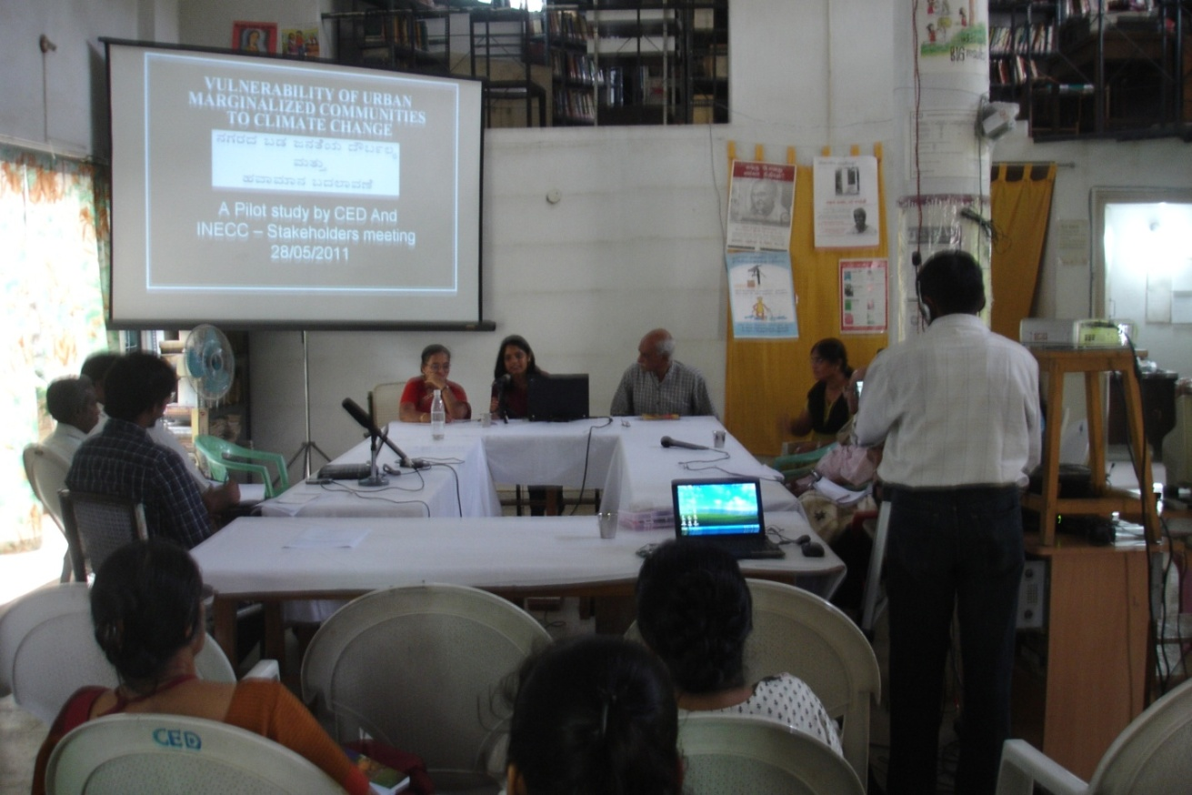
Stakeholder Workshop: Discussion on preliminary findings, validations of conclusions with peer NGOs, and researchers
In the stake-holders meeting to discuss the preliminary findings, and validate the findings, it was eminently pointed out by Dr. Sumi Krishna and Ms. Manjulika Vaz that the results are not so much quantifications of the occurrence or incidence, but provide episodic insights into the issues involved.

II.3 Areas chosen for Study: Rationale and Process

The areas were chosen from their counterparts because of the following reasons:
- KS Garden: Old slum in the core of the city; vulnerability to climate changes marked by the cramped houses and their proximity to the open drains, large number of homes.
- EWS Quarters: Typical example of relocation settlement and its attendant issues, the ability of the area to convey the vulnerability of its community due to forces beyond their control and institutional in nature, Kutcha homes that provide an insight into the exposure of its residents to climatic extremes and how the community adapts to these issues.
- Parappana Agrahara: Fringe habitat in the periphery of Bangalore, recently incorporated into the city’s limits, represents an ideal example of rural to urban transition, the community’s evolution to a more urban mindset, degradation of the nearby lake and possibilities of future disasters in the area because of this.

