III People & Livelihood
The households interviewed were mainly those where access of the local NGOs was maximum, and thus they represented the likely client groups of NGOs working in the area. Over 70% of the interviewed groups were women. They were more accessible and were not necessarily the “head of the household”.
Gender |  | KS | EWS | PA
Male | M | 14 | 19 | 14 | 47
Female | F | 41 | 35 | 31 | 107
Total |  | 55 | 54 | 45 | 154

In our discussions, only fifty percent of those interviewed gave clear responses on whether they had a rural or an urban background. A significant number of women said that they migrated due to marriage, a few for reasons of employment. About nine persons in EWS said that they came to secure a good education for their children.
Background |  | KS | EWS | PA
Urban | U | 14 | 14 | 5 | 33
Rural | R | 10 | 15 | 11 | 36
Total Responses |  | 24 | 29 | 16 | 69
Out of |  | 55 | 54 | 45 | 154

Reason for Migration |  | KS | EWS | PA
Marriage | 1 | 15 | 6 | 15 | 36
Moved with Household | 2 | 1 | 5 |  | 6
Education | 3 |  | 9 |  | 9
Work/employment | 4 | 8 | 7 | 4 | 19
Other-cheap rent | 5 |  | 1
Total Responses |  | 25 | 28 | 19 | 72
Out of |  | 55 | 54 | 45 | 154
Work/employment & Marriage | 4 & 1 | 1 |  |  | 1

Livelihood & Security
Most people come into cities to make a livelihood. Others to seek an education for their kids. Most of
them have left behind agriculture based livelihood. While in general a major reason for migration would be displacement either by projects or for social reasons, the reason for migration among the respondents to our study is indicative of the population in these three areas. The remaining residents have been in Bangalore for over two generations are unable to give a reason for their coming to the city, but speculate that it was non-profitable agriculture.

Range of responses | KS | EWS | PA
Low rainfall | 2
Non profitable agriculture | 1 | 1
Agricultural land acquired by the Government |  |  | 1

E25 is a 52 year old agricultural worker from Bihar. He owns 5 acres of land in Bihar on which he cultivated wheat. However with the onset of a labour crisis in the state, he could not manage. He came to Bangalore with his two sons leaving his wife behind, so that he could find a job and educate his children. Education is perceived as the prime economic mobility instrument. He now works as a security guard and stays in the tin sheds of EWS Quarters. Ganesh and his wife Venkatamma had no livelihood in Chitoor. They migrated to Bangalore and had to borrow Rs. 20,000/- from a brick kiln owner. Today both of them are working in the brick kiln as well as tend to the sheep of the owner, almost as bonded labour, in return for Rs.400 per week towards food expenses.

In Bangalore, the poor have to be content with whatever work comes their way. With all the effort, a majority of them earn less than Rs. 5000 a month. It goes up to Rs. 10,000/- per month.

Even the higher income families find it impossible to get out of the slum and go in for formal housing.
Further, due to lack of security of tenure, and their inability to take significant measures against major
perturbations individually, they can only resort to temporary and make shift arrangements.

In terms of occupations, they are usually coolies, or service workers.

Occupation |  | Number of respondents
 |  | KS | EWS | PA
Coolies: 46
 | Coolies | 14 | 12 | 20
Service Workers: 30
 | Drivers (taxi, lorries) | 5 | 0 | 2
 | Truck and lorry cleaners | 1 | 0 | 0
 | Hotel workers | 0 | 2 | 0
 | Carpenters | 1 | 0 | 0
 | Auto drivers | 4 | 0 | 0
 | Cable operators | 1 | 0 | 0
 | Contractors | 0 | 0 | 1
 | catering | 1 | 0 | 0
 | Tailors | 2 | 0 | 1
 | painters | 2 | 0 | 1
 | Electrical repair | 1 | 0 | 0
 | welders | 1 | 0 | 0
 | Grocers | 4 | 0 | 0
Service Jobs: 24
 | BBMP Workers | 5 | 1 | 3
 | CMC workers | 1 | 0 | 5
 | Watchmen | 0 | 2 | 1
 | Choultry helpers | 1 | 0 | 0
 | Office cleaners | 3 | 1 | 1
Employment: 9
 | Factory supervisors | 1 | 1 | 1
 | Senior factory employees | 1 | 0 | 0
 | Social work | 1 | 0 | 0
 | Acid factory employees | 0 | 0 | 1
 | Garment workers | 0 | 0 | 3
Informal Work: 33
 | Domestic helps | 13 | 14 | 5
 | Child caretakers | 0 | 0 | 1

The women tend to take up jobs which are part-time, like domestic help so that they can take care of their household duties. Further the burden of dealing with dampness, water logging, heat strokes, all climate related impacts falls on them. K26, is a single parent who migrated when agricultural labour was scarce in Tiruvannamalai, and had been working as domestic help for about 10 years. She has now taken up a house keeper’s job at the Bangalore Club. K32 for example is a grocer by occupation. She also owns a goat. The vegetables left over at the end of the day after her business form her goat's feed. P3’s Grandmother has been rearing goats for the last 15 years. She was also cultivating their two acres of land for Ragi, Paddy and vegetables, but the land has since been taken over for the Central Prison. She laments the fact that she now has to buy ragi, rice and vegetables which she would grow in the past. In fact food is the major expense, and the women in slums are usually seen foraging for job to ease the situation. P19 has a small kitchen garden in her backyard, where she grows vegetables that serve her family's needs. She grows runner beans, brinjals, fenugreek etc.

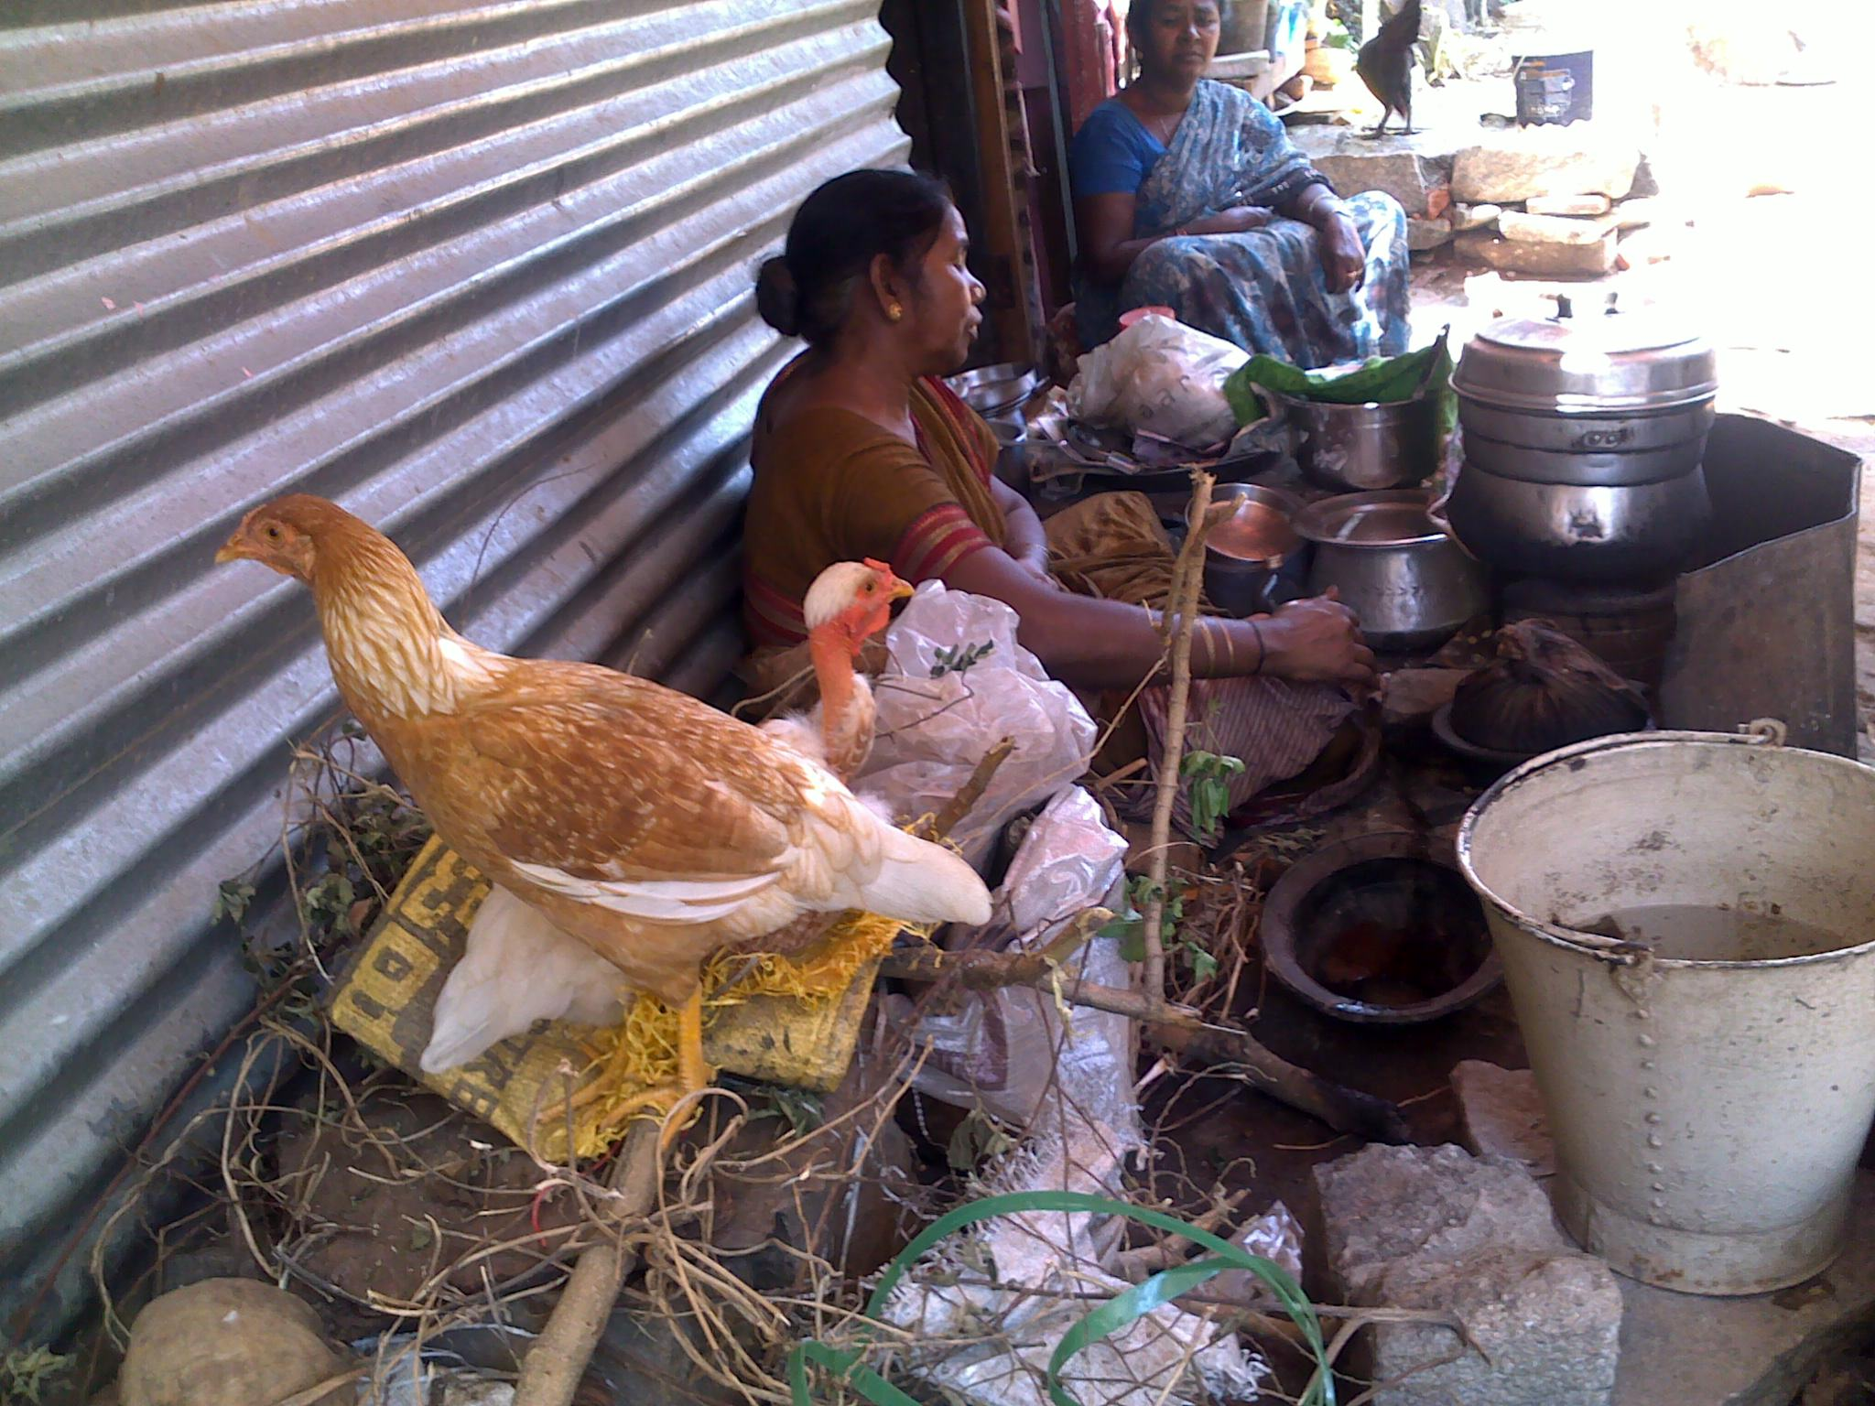
Women selling food in EWS
On the other hand Muniyalappa who has one acre in Parappana Agrahara, still grows one crop of ragi, and considers the 30 sacks that he gets from it, to be the best security and has therefore refused to sell his land. He also has two cows, a pair of oxen and 15-20 sheep. He has fenced his land with silver oak trees, and has a borewell. He is now planning to dig pits around his farm in order to allow rain water to recharge the ground water.
Provisions procured | KSG | EWS | PA
Provisions from ration shop |  | 12 | 2
Food from open market | 12 | 2
From both ration shop and open market | 1 |  | 1
Either ration shop or open market
Supplement the ration with purchase from Wholesale City market | 1 |  | 1
Bringing from Village | 3 | 1 | 1
No response | 36 | 39 | 39

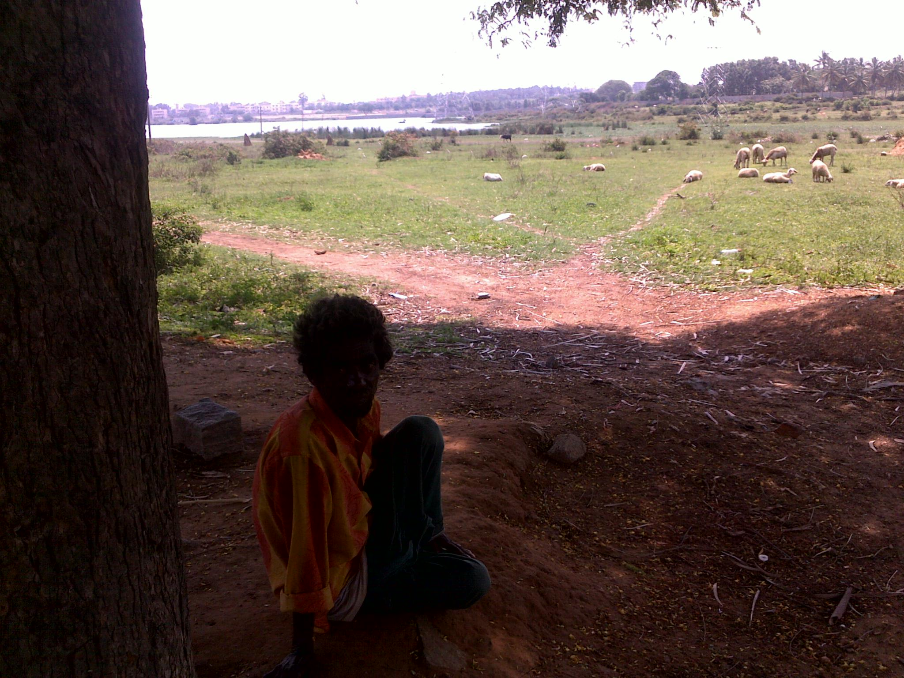
Herding sheep at Parappana Agrahara

