IV. Habitat
K S Garden (KSG)
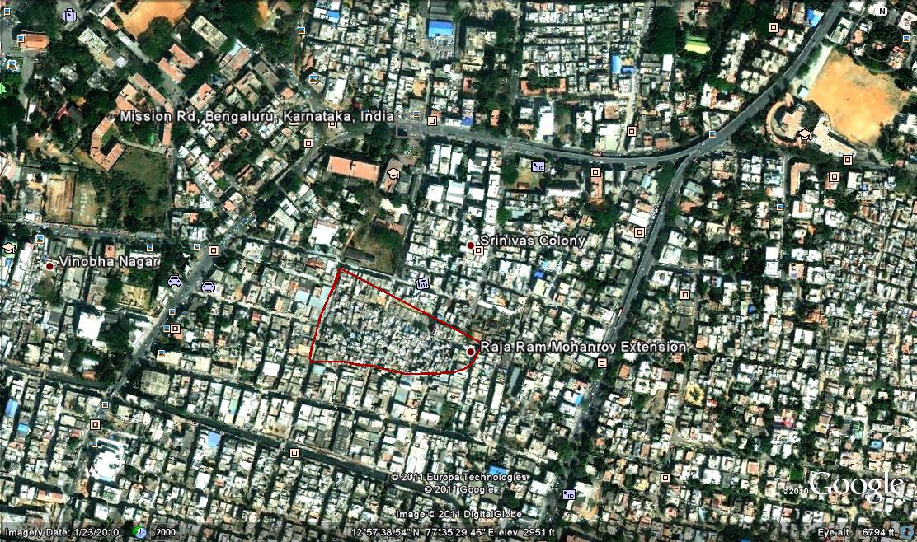

The Khader Sharif Garden Slum is in the heart of the city near the busy Double road (also called K.H.Road) and Lalbagh road and is more than 90 years old. Phase I of the slum has been notified and the land has been transferred to KSCB. Phase II is yet to be notified and the case is pending in the court. The slum is an old unplanned settlement consisting of around 1500 houses. The main approach road is at an elevation while the interior regions are very low lying. Thus the houses closer to the road which are at a higher elevation don’t get flooded. The more well-to do, have retrofitted or re-built their houses after elevating them by two to three feet. This seems to have exacerbated the problems of the poorer people, as the flooding that they experience is more severe.
The slum boasts of a community toilet facility which is well maintained by three persons paid directly from the collections from usage.
The slum has numerous kabaadi (paper and solid waste) recycling shops. There are many small transport operators closeby which provide employment opportunities. The people are mainly early migrants from Tamil Nadu, and have settled here for many generations. Most people are service workers like plumbers, painters, masons, carpenters, coolies and drivers. CIEDS originally started working with this group, and set up Shramik as a cooperative to take up these works for households around. This group now specializes in low cost construction, using Laurie Baker techniques, which has eventually led to the formation of the Centre for Vernacular Architecture.
The area is close to the BBMP (Bruhat Bengaluru Mahanagara Palike) office, and about 200 of them at present work in BBMP at various levels – peons, assistants, clerks etc. It is also close to the KR Market (Bangalore City Market) and many women retail vegetables in the locality after buying the older veggies at the main market at low prices. Some of the women breed chicken, hen and goats. The goats feed on the waste vegetables. The women also work as domestic help in the nearby localities such as Shanti Nagar, Langford Town etc. The people are mainly high schools dropouts, with a few degree holders.

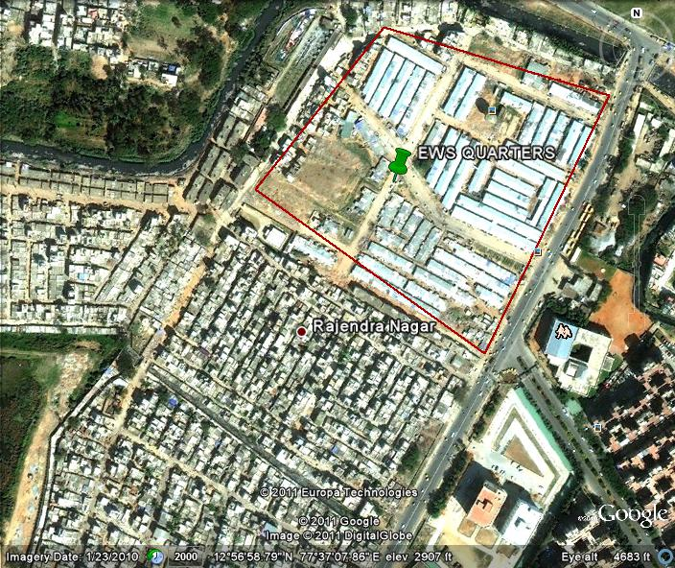
EWS Quarters (EWS)

The EWS quarters consists of about 1600 houses. The settlement is over 20 years old. It has been notified and people have been issued identity cards, though they may not be the original allottees. This was not a slum earlier. The location is called EWS Quarters because it was originally a complex of three storied concrete houses under the economically weaker section programme. The original allottees got rooms of 125 square feet each for Rs.42000/- payable over a period of 14 years under a HUDCO loan. However the buildings started collapsing after paying the first installment of Rs.2000/-. Following the collapse of one block, the then BCC had commissioned a structural viability study. This study had recommended demolition of 20 blocks apart from repairs to the remaining 21 blocks. However the then chief Minister ordered that the entire complex be brought down and reconstructed.

On its collapse, people were shifted to tin sheds, which did not have doors, or any amenities. Over time the residents made make-shift arrangements letting out the grey water from their houses. Some have dug pits in front of their house. In some of the lanes, residents got-together and constructed drainage of pipes, leading the grey water to the storm water drain on the main road. Two waste management units operated by Saahas and Center for Social Action are located in the area.

The location is totally devoid of any tress and vegetation, and is largely low lying. The people are mostly service workers comprising painters, welders, carpenters, auto-rickshaw drivers as well as coolies and security guards. The women work as domestic help in the nearby areas of Ejipura, Viveknagar and Koramangala.

The area is surrounded by middle class residences and shops namely Samatha Nagar, Koramangala Main Road, Passport Office, Bangalore One Centre etc. National Dairy Research Insitute, St.Johns and Infant Jesus Church are also prominent institutions in the area.

Parappana Agrahara (PA)

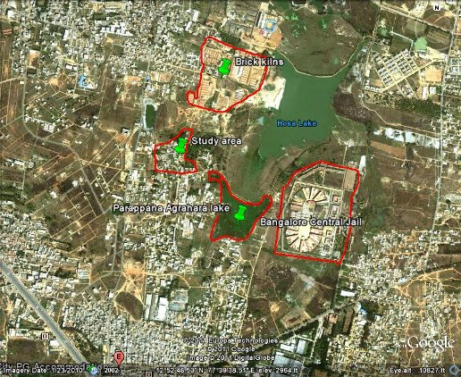
This is an old village which has been recently integrated into the BBMP limits and is still technically a village, and not notified as a slum. The village is located near the Electronics City, or rather the IT and Biotechnology hub of the city that has now come up near the area.

The main problem of the residents is that the Central Jail, which was relocated on the other side of the Parappana Agrahara lake village in 2001, dumps all its effluents without much treatment onto the lakes. Around 150 acres of agricultural land belonging to this village was acquired to start the prison in the 80s. The area is close to the industrial area of Bommanahalli, and most of the male members of the family would work in the factories, industries there, while the women took care of the agricultural work. The women were therefore dependent for their livelihood on rain and on the lake, and therefore lament the deterioration of the lakes and environment. There were a few families living on fishing in the lakes. Other occupations include weaving. The current composition is mainly that of migrants from Karnataka and Tamil Nadu, who came as contract labourers. Now the village has quite a few Pourakarmikas who work in closeby areas such as Bandepalya, Singasandra, Garvebhavi Palya, all which have come into BBMP limits since March 2010. Many people of older generation have not received any formal education. Among the younger ones, there are a large number of school drop-outs. There are a few graduates though.

The village has around 400-450 houses, at a relatively high elevation. Very few families have toilets and bathrooms inside their homes and open defecation is the norm.

Nature of Housing

Slums in the core of the city, as in Khader Shariff Garden are generally very crowded. The living spaces are also very small, and as the family expands, it gets more cramped. K34 for example says that when their son got married, they rented another room in the neighbourhood, which they used as a bedroom. It becomes like an extension of the main home, and the inter-room space is adapted for drawing purposes, as well as for drying clothes, water storage, resting on a hot afternoon. Given the continuous retrofitting, slum dwellers, except in the extreme cases do not see their habitat in static terms like katcha or pucca. They are all somewhere in the continuum between the two.

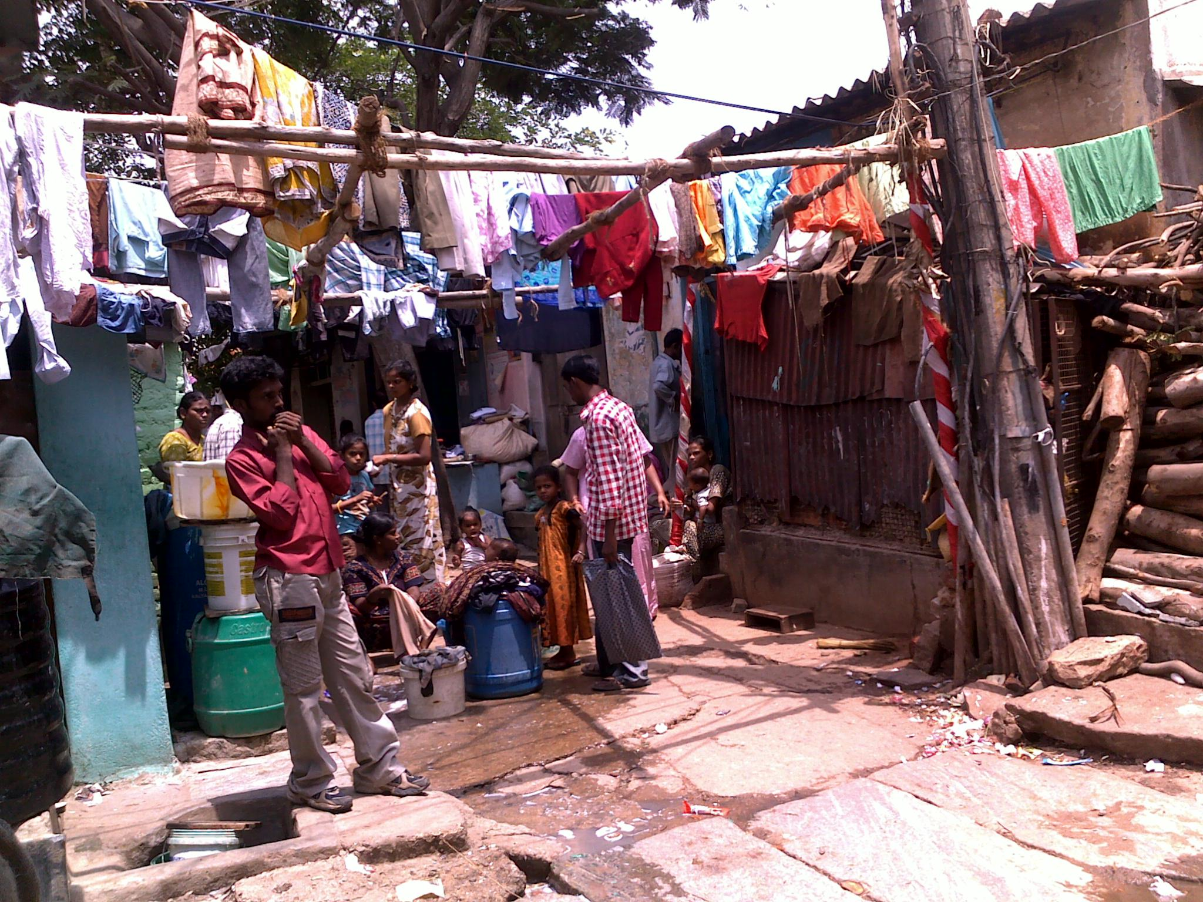
Type of House |  | KS | EWS | PA
Katcha | 1 | 3 | 50 | 2 | 55
Semi Pucca | 5 | 7 |  | 6 | 13
Pucca | 10 | 28 | 2 | 29 | 59
Total Responses |  | 38 | 52 | 37 | 127
Out of |  | 55 | 54 | 45 | 154

The people are able to characterize the type of flooring, walls, and roofing more clearly. In KS Garden the roofing is mainly asbestos sheets, flooring and walls of cement. Some in KS Garden even had tiled flooring. EWS scores badly because of the temporary nature of tin construction with a large number of mud floors.

Type of Roofing |  | KS | EWS | PA
Grass/Thatched | 1
Tarpaulin | 2
Wooden | 4 |  |  | 1 | 1
Corrugated Tin sheet | 5 |  | 50 | 1 | 51
Corrugated Asbestos sheet | 6 | 33 | 1 | 32 | 66
Tiled | 8 | 6 | 1 | 1 | 8
Cement/Slab | 10 | 11 | 0 | 4 | 15
Total Incidences |  | 53 | 52 | 39 | 144
Total Responses |  | 47 | 52 | 39 | 138
out of |  | 55 | 54 | 45 | 154
Asbestos and Tiled | 6 & 8 | 1 |  |  | 1
Asbestos and Cement | 6 & 10 | 2 |  |  | 2

Type of flooring |  | KS | EWS | PA
Mud | 1 | 0 | 25 | 2 | 27
Brick | 2
Stone | 4 | 1 | 2 |  | 3
Cement or Red Oxide | 8 | 29 | 25 | 31 | 85
Tiles | 10 | 17 |  | 6 | 23
Total Responses |  | 47 | 52 | 39 | 138
out of |  | 55 | 54 | 45 | 154

Type of Walls |  | KS | EWS | PA
Tin | 1 |  | 50 |  | 50
Mud | 2 | 11 |  | 4 | 15
Stone | 6
Brick | 8 | 4 |  | 3 | 7
Cement | 10 | 35 | 2 | 31 | 68
Total incidence |  | 52 | 52 | 38 | 142
Total responses |  | 48 | 52 | 38 | 138
out of |  | 55 | 54 | 45 | 154
Mud and Cement | 2 & 10 | 2 |  |  | 2

The houses of the respondents to our study within Khader Sharif were for the most part pucca to semi pucca structures, the only exceptions being K2, K3, K9, K12, K13, K25 and K31 who lived in semi pucca dwellings with tiled roofs, mud walls and mud-floors patched-up with cement. K4 lives in a completely katcha frame where the roof is thatched and the walls were made of mud. The monthly income of the respondents who lived in the semi pucca homes ranged between Rs.1800 to Rs. 4000, an exception here again being K13 who has no source of income. K13 is an elderly woman whose husband has passed away and whose children have abandoned her. She however has the land on conditional ownership, but meets her essential requirements through the generosity of her neighbours. This low scale of income in these families could account for the houses not being renovated in time to stop the ravages that nature inflicts on them.

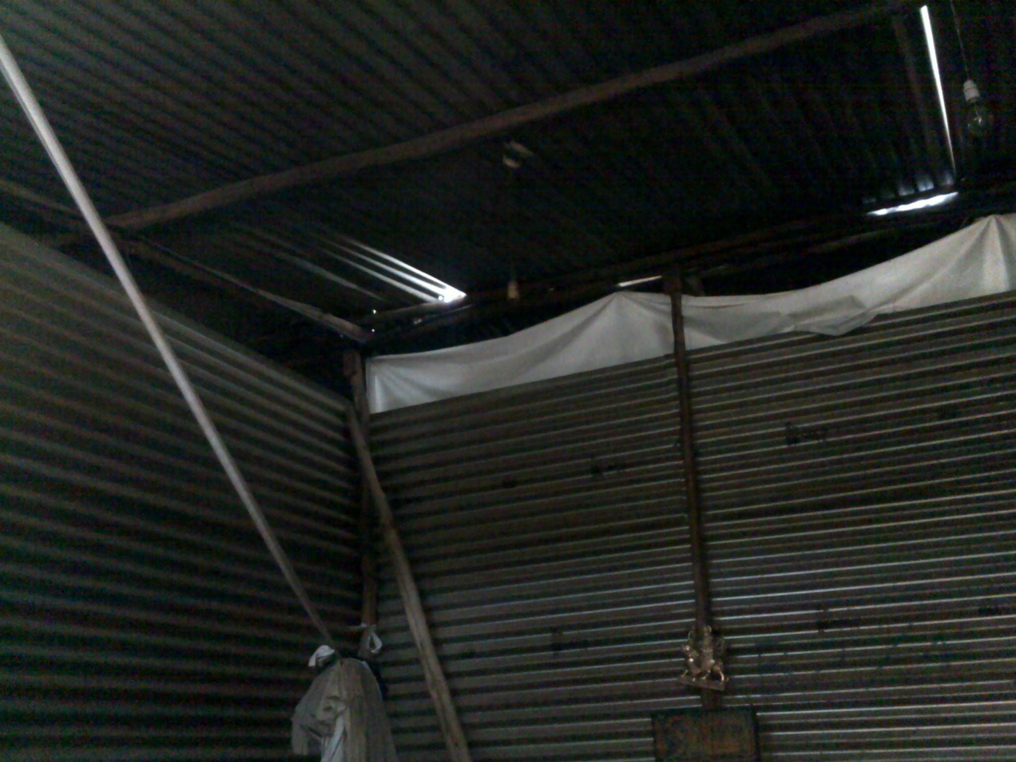

The EWS Quarters, whose surrounding areas now include the posh neighbourhood of Koramangala, is situated near four other slums. It was actually a set of three storied structures built for Economically Weaker Sections programme in 1986 with a Rs 2.23-crore HUDCO loan. 80 year old, who served as the watchman for the entire colony, and resided at Block 13 recalls that the JCBs which were sent to clean the drains operated carelessly, damaging the foundations of the blocks, thus resulting in some blocks developing cracks and eventually collapsing. But the fact remains that owing to poor construction, two to three buildings collapsed during every monsoon between 2003 to 2008. The remaining blocks were bulldozed for safety reasons.

Since then the people have been forced to live in tin sheds. In the rains, there is heavy leakage of water, which creates short-circuits. The electricity is cut off for periods upto three days. The residents however accept this, as they fear short circuits resulting in electrocution within their tin sheds. A few homes have stone or cement floors, but for the most part flooring is of mud type. The only exceptions to this form of housing were those residents who lived in Samathanagar, a stone’s throw away from and adjacent to the EWS Quarters. These residents were E8 and E9, whose homes were pucca with E8 having mould roofing as well. She has witnessed the roof of the tin sheds in poorer homes fly off during heavy storms. E9 who had a pucca home with asbestos roofing, has settled on the land, however unofficially.

E25, 52, a security guard in Bangalore, has been living in EWS quarters for eight years. He hails from Bihar. He owns 5 acres of land, where he cultivated wheat. Due to a shortage of agricultural labour there, he was not able to continue his agricultural operations there. He felt that he needed to educate his children, and therefore he brought his two sons to Bangalore and left his wife behind to look after the fields. He now lives in a tin shed in EWS quarters. During the rainy season he protects himself by putting tarpaulin sheets on the roof and on the walls.

Parapanna Agrahara still has a rural feel to it. Its houses have been developed over time, and many of them live in pucca houses. As they were situated close to industrial development areas, many of them have jobs in factories and have been able to invest in their houses. The exceptions are in semi pucca dwelling (P3, P9, P25, P27, P30, P34, P38, and P43) The income of these respondents range from Rs.2500 to Rs.5000, the only exception being P38, who having an income of Rs.10, 000 did not ascribe to the hypothesis that lower the income, the poorer the nature of housing in this locality. P41 was the only respondent interviewed who lived in a katcha dwelling. Her family’s income was Rs.4000.

While it follows that in general within the studied areas and among the respondents interviewed, the nature of housing is not a direct function of the income, it has been noticed that people who have low incomes tend to undertake fewer renovations or retrofitting within their homes, making them more vulnerable to experiencing harsh weather conditions in a more acute manner.

A very important indicator of ways of coping became apparent to us when we visited the EWS quarters in July during the rains to verify some unclear facts. Many people have re-done their homes by cementing, or upgrading their bathing spaces. It seems to be a regular pre-monsoon activity. Even the government works tend to fructify just before the monsoon as we saw that a full stretch of new tin sheds had been constructed and people who were in very old tin sheds have relocated into these new ones.

BCC wants pvt builder to build Ejipura quarters, Dec 5, 2003, Times of India, http://articles.timesofindia.indiatimes.com/2003-12-05/bangalore/27197786_1_bcc-bangalore-city-corporation-ews-quarters

