V. Civic Amenities
V.1 Sanitation & Waste
In Bangalore, the system of sewers for the conveyance of domestic and industrial waste water through underground drainage system was introduced in the year 1922. It initially was confined to heavily populated area in the heart of the city and although a gradual extension took place then onwards it was not until 1950 that a major programme of sewer construction was commenced.
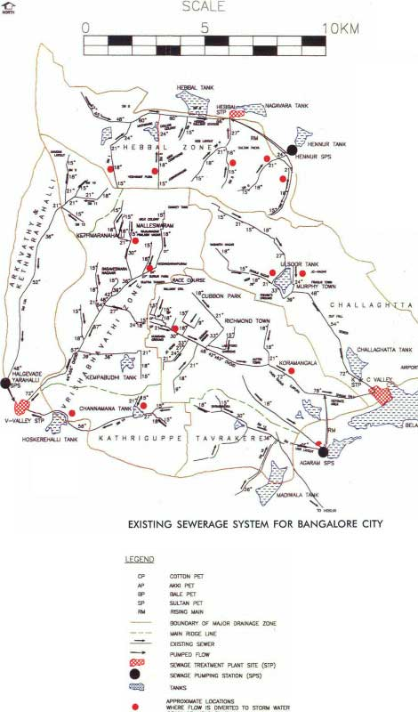

With the formation of the Board (BWSSB) in 1964, the programme to provide Sewerage system in the unsewered areas was taken up in a phased manner and the treatment of sewage before it is led into the natural valleys was also tackled. (http://www.bwssb.org/sewerage_system.html).

Both sewerage and storm water flow by gravity beyond the city. However, it is widely known that the sewerage treatment systems are well below par in the city. Further, expansion of the sewerage infrastructure in the city can treat only 18.6% of the city’s total sewage output. Furthermore, in many parts of the city, the network of pipes that connect the STPS to the drainage is missing, old or damaged and industrial effluents are being let off into storm water drains, further impacting the city’s natural water bodies.

Living in over crowded conditions brings in its own hazards, primary among them is the required intensity of Sanitation and Solid Waste disposal facilities.

The following are the incidence of various sanitary amenities among the persons interviewed

Bath Facilities |  | KS | EWS | PA
Open water bodies – lakes/ponds | 1 |  |  |  | 0
Community baths- paid | 2 | 2 | 2 |  | 4
Community baths – free | 3 |  |  | 2 | 2
Individual baths at home | 4 | 53 | 50 | 41 | 144
Total Responses |  | 55 | 52 | 43 | 150
out of |  | 55 | 54 | 45 | 154

Purification of Water |  | KS | EWS | PA
None | 1 | 33 | 38 | 22 | 93
Filtering | 2 | 6 | 2 | 13 | 21
Adding chemicals – alum/potassium permanganate | 3
Boiling | 4 | 14 | 10 | 15 | 39
Total incidences |  | 53 | 50 | 50 | 153
Total responses |  | 52 | 51 | 40 | 143
out of |  | 55 | 54 | 45 | 154
none& boiling | 1&4 | 1 |  | 1 | 2
Filtering& Boiling | 2&4 |  |  | 9 | 9

The household interviews in the three areas revealed that KS garden, which is in the heart of the city, and the oldest, had BWSSB drainage connection, whereas in the so called planned settlement under economically weaker sections, the connections were to open drains in 27 out of the 54, and 12 households have a pipe going to the corner of their own shed. And in Parappana Agrahara, which has only recently been brought into the corporation, 16 let their grey water into open plot nearby whereas the seven who had septic tanks for their toilet, claimed to let their grey water into the same pits.

Grey Water Drainage |  | KS | EWS | PA
Pipes leading to neighbouring public/private property | 1 |  | 6 | 16 | 22
drains leading to storm water drainage facility | 2 | 1 | 27 | 3 | 31
Open drains leading to collecting chamber | 3 | 4 | 12 | 16 | 32
BWSSB sewerage connection | 4 | 47 | 4 |  | 51
Total Responses |  | 52 | 49 | 35 | 136
out of |  | 55 | 54 | 45 | 154

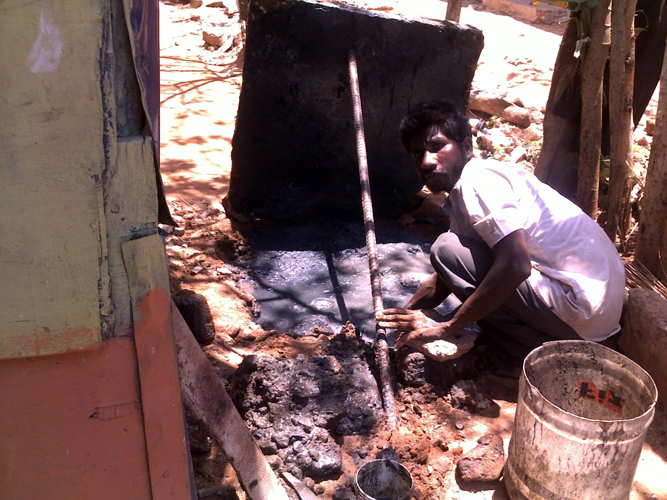

EWS Quarters, the tin sheds have not been provided with drainage facilities. The families that live towards the periphery of the slum, facing the main entrance divert the sewage generated in the homes to the open gutter that lines the street. We also observed one family diverting the sewage to a pit in the corner of the shed. This pit was being cleaned using bare hands by the residents of that shed.

Khader Sharief Garden boasts of an official sewage connection from BWSSB. However since the lanes are very narrow, the cylindrical concrete chambers which were constructed in between houses, are either too small or at a shallow depth. Due to poor construction and maintenance, there is seepage of rainwater into the chambers raising the level of sewage above the inflow mark, resulting in the sewage flowing back into the toilets, as well as the bath and wash spaces in the houses. It is for this reason that 47 persons prefer to use the community toilet system. (only 9 people have individual toilets using the BWSSB facility). In the neighbourhood discussion, the people estimated that only 400 houses had internal toilets, whereas the 24 cubicle community toilet served the remaining 1100 families. We also observed that many children do not use the toilets.

Toilet Facilities |  | KS | EWS | PA
Open fields | 1 |  | 1 | 23 | 24
Community toilets- paid | 2 | 47 | 41 |  | 88
Community toilets - free | 3 |  | 1 |  | 1
Individual toilets in home | 4 | 9 | 9 | 21 | 39
Total Incidence |  | 56 | 52 | 44 | 152
Total response |  | 55 | 52 | 44 | 152
Out of |  | 55 | 54 | 45 | 154
Paid & Home | 2 & 4 | 1 |  |  | 1

In the event of heavy rains, when overflow levels are reached, low-lying areas within the slum are inundated by a mixture of sewage as well as storm water.

The community toilet system here is two sets of twelve toilets built by the government in 2005.The toilets are maintained by the community. Users are charged Re.1 per use, and the proceeds are shared by the three persons maintaining the toilet. Every two months or so, the pipes get clogged, and the workers attend to the problem immediately.

The number of toilets are clearly not enough, as there is a long queue during peak hours, due to which the toilets are open as early as 4 am. All cubicles are kept locked at night, with the exception of one disabled- friendly toilet, which is used in an emergency. The new toilet complex gets piped water which is a big relief as people do not have to carry water, and proper flushing takes place, as compared to the earlier 40 year old complex.

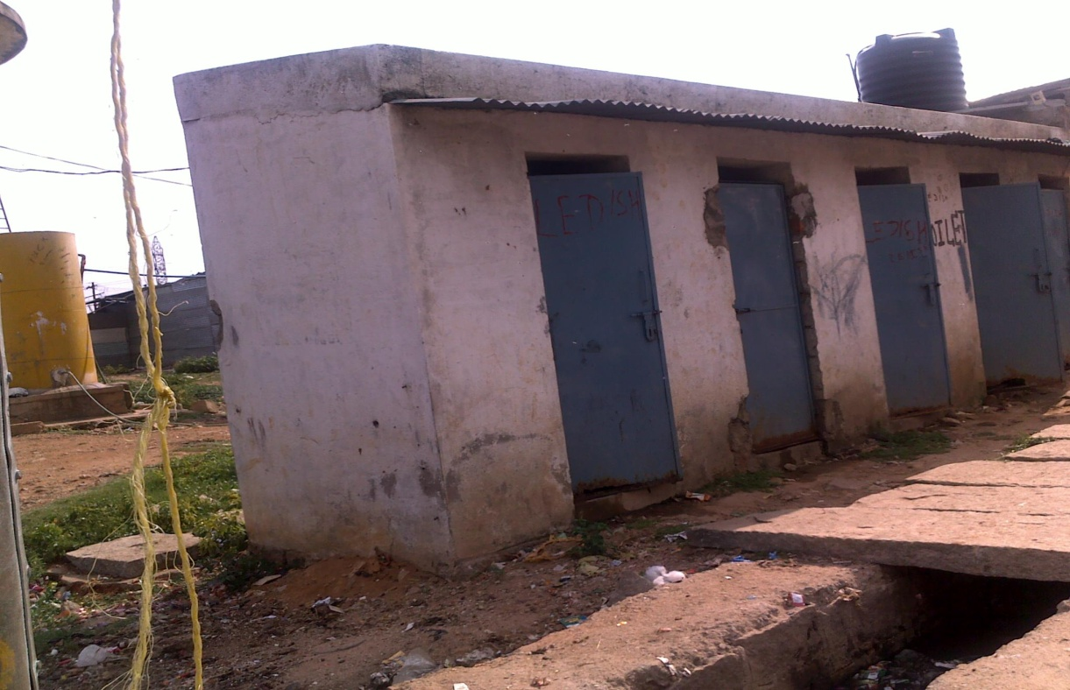

In EWS Quarters with over 1,512 households, i.e. a population of 6500 people has to use 4 toilet complexes of 5 cubicles each, half of which have been dysfunctional for a long time. In addition, clogging is frequent, nearly once every three days. Unlike in KS Garden, the community toilets are not maintained locally, rather they have to wait for authorities to fix any problem. 9 out of the 54 respondents to our questionnaire have made individual arrangements, which may not be very sanitary. One of them pointed out that the reason for opting for individual toilets was safety of the young girls of their household.

Parappana Agrahara is a village that has recently been introduced into the BBMP ward limits and drainage connections are virtually non-existent. There is no community facility, and a large number of people still do not use toilets of any kind. Among the 45 households interviewed, 3 had their toilets sending their black water to storm water drains, and seven into poorly constructed soak pits indicating major vulnerability in case of heavy rains. One family has an individual toilet in their home which was constructed with support from the maternal home of the lady as they have young daughters and due to concerns regarding their safety with the practice of open defecation. Sewage water from their home flows into neighbouring open plots and the family is voicing concerns about what will happen when buildings are constructed on these plots. They say that the community has been approaching the concerned authorities for a proper drainage connection for the last 2 years but to no avail. This house is in an interior location of the village and due to this it is often ignored by the garbage collection vans. Therefore she dumps her wastes into a neighbouring plot and sets them ablaze once a week in order to keep the plot tidy.

The overall sanitation situation in all three locations were such that they are very vulnerable to rain, and with the increasing unpredictability of rains, particularly extreme conditions, as are predicted in a climate changing environment, their vulnerability is bound to get worse. Thus reducing vulnerability of these slums would mean improving the sewerage and type of toilet facilities and the various methods of disposal of solid wastes in these slums.

We gave a score according to predominant notions of sanitations as under, to plot the level of services.
Type of toilet
Open fields | 1
Community toilets-paid | 2
Community toilets- free | 3
Individual toilets in home | 4
Type of bathroom
Open water bodies –lakes/ponds | 1
Community baths - paid | 2
Community baths - free | 3
Individual baths at home | 4
Drainage facilities
Pipes leading to neighbouring public/private property | 1
Closed drains leading to stormwater drainage facility | 2
Open drains leading to collecting chamber | 3
BWSSB sewerage connection | 4

When the respondents were plotted within their own slum, the sanitation facilities showed a marked similarity within each slum.
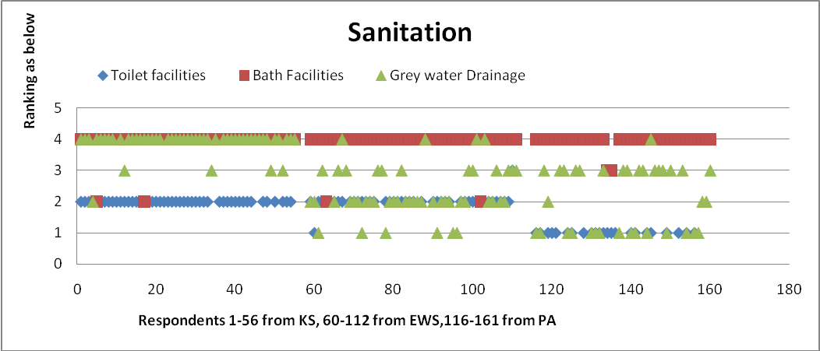

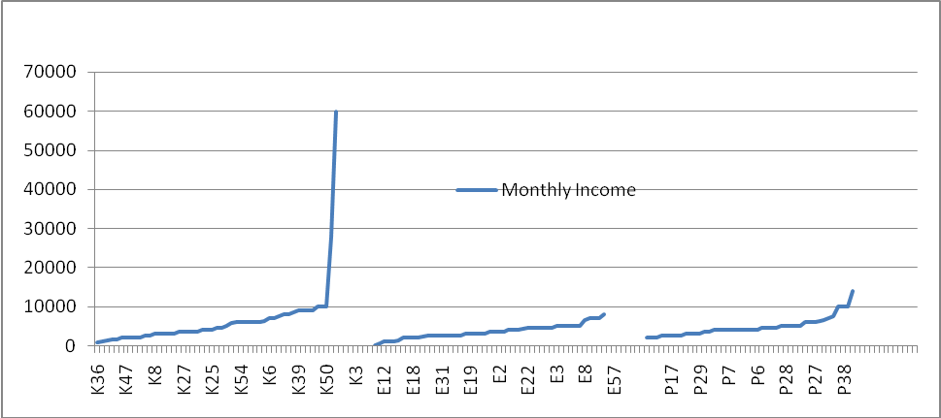
This indicates that it is related to the history of the slum, with the majority in KS garden and EWS Quarters using community toilets even when they have to pay for it. When we look at each slum, there is a correlation, though a bit episodic, showing an upward trend as the nature of housing gets better. Thus, indicating that some families tend to incorporate a separate toilet within their premises as well along with better housing. However, in Parappana Agrahara, the increase in permanence of dwellings does not translate into a better toilet facility in many cases.

When we plotted the same sanitation facilities, according to income (chart below), there isn’t much significant change in the pattern of disposal of waste, though the incidence of higher type of toilet for higher incomes is discernable.
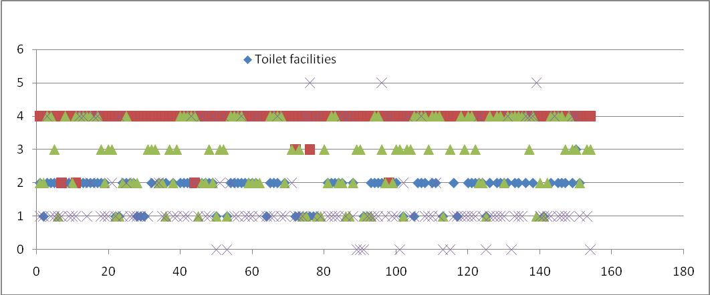
.

It is seen that in Khader Sharief garden only 14 families have individual toilet systems and the income range of these individuals range from Rs. 4000 to Rs. 60,000, on an average higher than other residents within the same area. Within EWS quarters, only 8 respondents have individual toilets and this measure has been incorporated for security reasons and is not a function of their income. In Parappana Agrahara, however, a sharp skew is observed, indicative of the fact that family income is not a function of the toilet facilities of the household. This suggests that the facility arises out of an infrastructural need and not so much by the income in this area.

Thus for any robust resilience to vulnerability, the community would have to invest in good sewers, and toilets at the community level if not possible at the individual level. But such investments are not likely to be made individually even among the higher income groups.

Disposal of Solid Waste
The disposal of solid waste in Bangalore is reliant on collection of solid waste in motorized vans. The Vans make their round daily, and people are expected to come down with their waste and deposit into the Van. Residents in Apartments generally organize a private door to door collection, and from there it is deposit into the moving van. Even so, many residents in so called middle class localities tend to throw their waste into open space/corners. These spaces become places for stray animals to forage and they are generally messy and smelly. In most slum areas, the by-lanes are too narrow for motorised vans to come in, and so Community bins, are provided. Generally the entire space around it is quite a mess. E14 complained that waste disposal systems were very poorly managed.

Solid Waste Disposal |  | KS | EWS | PA
Throwing into empty plot | 1 |  | 2 | 12 | 14
Throwing into open drain | 2 |  | 9 | 2 | 11
Segregating and composting | 3
Burning | 4 |  | 1 | 1 | 2
Community bins | 8 | 41 | 4 | 3 | 48
Collection Vans | 10 | 6 | 36 | 26 | 68
Total incidences |  | 47 | 52 | 44 | 143
Total responses |  | 47 | 52 | 37 | 136
out of |  | 55 | 54 | 45 | 154
Throwing into empty plot & drain & burning | 1,2,4 |  |  | 1
Throwing into empty plot & drain | 1,2 |  |  | 2
Throwing into empty plot & collection van | 1,10 |  |  | 4

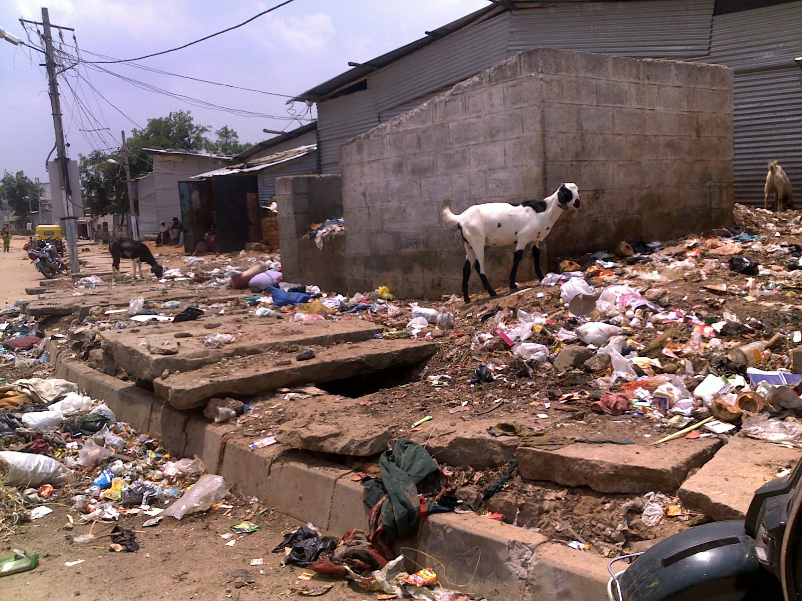Waste dumped in EWS Quarters

V.2 Water availability & Usage
Urban water systems will be affected by most of the predicted climatic changes: droughts will affect water supply and higher temperatures, besides increasing evaporation in supply lakes, could lead to the deterioration of water & water pipes contaminating fresh water. This risk, sits over and above other factors which threaten urban water supply like deforestation of catchment areas, reduction of seepage due to urbanization, and contamination of aquifers by modern development. The BWSSB which supplies piped water to Bangalore sources it from the Cauvery River (about 80% of total water supply) and the Arkavathy River (about 20% of the total water supply).
In its website, the BWSSB admits that the per capita water supply at present in Bangalore is about 100 to 125 (gross) liters per capital per day (LPCD) which is below the National Standard of 150-200 LPCD for a city like Bangalore. However, the per capita availability of water for vast majority of poor people in Bangalore is only about 40-45 LPCD. One of BWSSB mandates is to provide bore wells in slums and poorer areas.
The quality of water received in any slum, varies depending on the source and the extent of pollution.
The graph below shows that both the city area settlements, KS Garden and EWS garden source a combination of BWSSB Cauvery water and borewell water, whereas Parappana Agrahara is mainly reliant on borewell water.
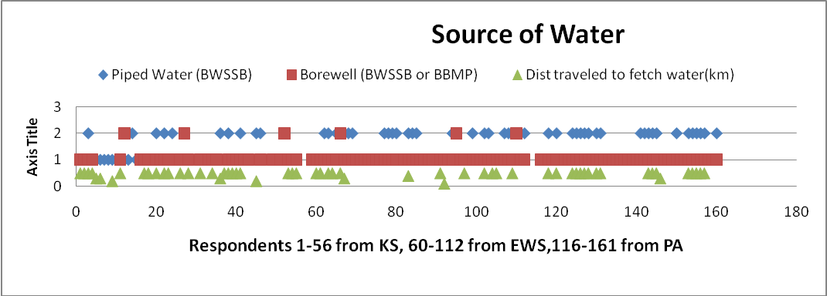
The Cauvery water supply is limited to alternate days. People have to store double their daily requirement of water, if not more for emergencies. The graph tells us that of the 55 respondents in KS Garden, only 14 respondents, collect over 30 pots of water which is about 120-150 lpcd of water. Of these 14 respondents, a few like K6 and K16 capture at about 60 and 40 pots of water respectively. However, K4, K12, K38 and K55 have access to only less than 10 pots of water every alternate day, with K55 accessing only 3 pots of water in a day. In the neighborhood survey, we were told that over 50-60% of the dwellers do not have a BWSSB Cauvery water connection, and therefore they have to rely on neighbours for the drinking water requirements.
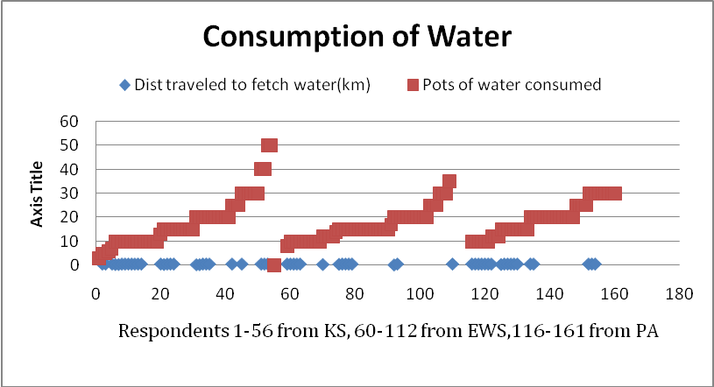
The piped water supply near each lane in EWS Quarters comes from water tanks containing bore well water on every alternate day. The average number of pots of water collected range between 10 and 20, approximating to 50-100 lpcd per capita per day. Of the 54 respondents interviewed only 6 respondents collected more than 20 pots of water. In fact E5, E6 and E9 have reported usage of only BWSSB water for their domestic uses. E24 and E30 stood far below the average at 8 and 2 pots of water respectively. This is usually due to the fact that the men and women are away at work at the time of supply. These families have to resort to reducing the water usage by things like bathing on alternate days.

To make up for the shortfall of water, the lower consumers, use the water from the community level bore well for cleaning, washing and other purposes.

Cooking Water source |  | KS | EWS | PA
BWSSB | P | 34 | 47 |  | 81
Borewell | B | 5 | 5 | 29 | 39
Tanker | T | 1 |  |  | 1
Community Tap | CT | 1 |  | 5 | 6
Rain Water Harvesting | RWH | 0
Total incidence |  | 41 | 52 | 34 | 127
Total Responses |  | 35 | 50 | 34 | 119
out of |  | 55 | 54 | 45 | 154
BWSSB & Borewell | (P & B) | 5 | 2 |  | 7
BWSSB & Borewell& tank | (P&B&T) | 1 |  |  | 1

Bathing Water Source |  | KS | EWS | PA
BWSSB | P | 30 | 42 |  | 72
Borewell | B | 19 | 48 | 29 | 96
Community Tap | CT | 2 |  | 5 | 7
RWH | RWH |  | 1 | 4 | 5
Total incidences |  | 51 | 91 | 38 | 180
Total Responses |  | 34 | 50 | 34 | 118
out of |  | 55 | 54 | 45 | 154
BWSSB & Borewell | (P&B) | 17 | 40 |  | 57
BWSSB & Borewell & Rain | (P&B& RWH |  | 1 |  | 1
Borewell & Rain | (B & RWH) |  | 1 | 2 | 3
Community Tap & Rain | (CT & RWH) |  |  | 2 | 2

Cleaning Water Source |  | KS | EWS | PA
BWSSB | P | 22 | 41 |  | 63
Borewell | B | 25 | 49 | 29 | 103
Tanker | T | 2 |  |  | 2
RWH | RWH |  | 1 | 6 | 7
Community Tap | CT | 2 |  | 5 | 7
Total incidences |  | 51 | 91 | 40 | 182
Total Responses |  | 22 | 50 | 34 | 106
out of |  | 55 | 54 | 45 | 154
BWSSB & Borewell & Community Tap | P & B & D | 1 |  |  | 1
BWSSB & Borewell | P & B | 16 | 40 |  | 56
BWSSB & Tanker | P & Tanker | 1 |  |  | 1
BWSSB & Borewell & Rain | P&B & RWH |  | 1 |  | 1
BWSSB & Rain | B & RWH |  | 1 | 2 | 3
Community Tap & Rain | CT & RWH |  |  | 4 | 4

Rainwater collection |  | KS | EWS | PA
Y |  | 7 | 17 | 13 | 37
N |  |  |  | 8 | 8
Total Responses |  | 7 | 17 | 21 | 45
out of |  | 55 | 54 | 45 | 154

Some even salvage whatever rainwater they can from leaky roofs. The community also has to contend with contaminated water. E19 mentioned TV9 and other television channels filmed the bad quality of water, filled with worms and other problems, but after all that hue and cry, the problem still persists. There is also the problem of water mafia who charge the users for this free water. Thus they have a vested interest in keeping water in short supply.

In Parappana Agrahara, the water source is two community level bore wells supplied by the CMC, before the area was incorporated into the BBMP. Compared to earlier when they drew water from open wells, they do collect what they consider sufficient water, as they now have to ferry it for shorter distances.

P2 recalls when she had moved to Parappana Agrahara after her marriage, the lake had a lot of water. Now it is full of weeds. P3 mentioned how lower castes were not allowed access to open wells in the Reddy locality, and were dependent on the lake for meeting their water requirements. However since the jail has been relocated to this area, the water of the lake has slowly become contaminated.

Over the years, the water level in the borewell has gone down, and the water contains a lot of salts. The open wells have been filled up. In earlier days the community, used to draw water from the lake for its domestic purposes including drinking. However, the effluents from the recently shifted Central Jail, has made the water unfit for consumption.

Only 4 families among the interviewed people, receive water everyday from the borewell close to their homes.

P5 has a big synthetic tank in which she stores water. She does allow her neighbors to use this water in emergencies, but that is rare. But as mentioned by P7, the water source is drying up. He said that 5-10 years ago, one used to get 4-5 inches depth of water every day from the bore well, whereas today, not even 2 inches depth of water is available from the same source. The open wells have already dried up. This situation is likely to get exacerbated due to climate change.

The other issue in Parappana Agrahara is the presence of salts, which forms a thick deposit in the vessels upon heating. Thus the residents avoid boiling water. They also cannot use geysers or immersion heater rods.

The Comptroller and Auditor General has observed that 53% of the 920 MLD (Million litres per day) of sewage generated by Bangalore is discharged directly into stormwater drains and lakes, contaminating water bodies and groundwater". The groundwater quality in BMR(Bangalore Metropolitian Region) was affected due to presence of pollutants in excess of permissible limits". (http://www.dnaindia.com/bangalore/report_over-half-of-bangalore-s-sewage-flows-into-storm-waterdrains-lakes-report_1520311)

Even this is in short supply as is evident from the complaint by one of the respondents, that certain gangs control this water and charge a fee for what is supposed to be free to the community.

Even in such a situation, people do not have the means and wherewithal to treat the water. Most of the people interviewed indicated that they do not boil or treat the water. K12 said that the shortage (high cost) of kerosene makes it impossible to boil water.

V. 3 Energy

Energy Use is a critical contributor to Climate Change. It is also a critical factor for development.
For the Urban poor, Energy use is mainly in four areas
a) Lighting and Heating
b) Conveniences like Fans, TV, Electric Iron
c) Cooking Both Electricity based like Mixer, Grinder, and cooking fuel like Kerosene, firewood and LPG.
d) Transportation to Work.

ELECTRICITY:
In the City, the most convenient method for Lighting and Heating as well as conveniences would be electricity. The Urban poor who have settled into slums do have basic access to electricity. However within Parappana Agrahara, we were told that there were cases where residents had not been provided with electricity at all.

Electric Connections | KS | EWS | PA
Metered electric connection | 41 | 0 | 16 | 57
Non metered electric connection | 2 | 0 | 0 | 2
Free connections from Pole |  | 51 |  | 51

The Slum Declaration Act provides that slum areas should be provided with electricity and other amenities at a subsidized cost. Yet there are a few households which find it convenient not to have independent meters, and borrow electricity from neighbours by paying them a fixed monthly charge. The reason for this could well be a disconnection due to default in payment or other reasons.

The Electricity infrastructure is very unstable. Open transformers, overhead transmission and distributions lines, ensure that every rain brings with it short-circuits, exposed wires etc. and extended periods of power cuts. Respondents from the area seem reasonably satisfied with the service except for the occasional load shedding. Unlike in rural areas, voltage fluctuation is not severe and occurrence of extreme low voltage is not perceived. A frequent complaint was that when disruption of supply does occur, it remains so for around two days. However in EWS power cuts associated with short circuits due to rains, are welcome, as a safety measure. During monsoons, given their unstable metal housing structures, the risk of electrocution is high.

The usage pattern of the electricity given below, shows that the most predominant usage is one or two bulb, or fluorescent tubes for lighting, a fan for cooling, and TV for entertainment. The mixie is also in popular use. These along with one or two dysfunctional fridges, or washing machines, seem mainly items which have been salvaged or hand-me-downs, as many were reported in state of disrepair.

Lighting |  | KS | EWS | PA
Bulb |  | 30 | 53 | 23 | 106
Tube |  | 30 |  | 7 | 37
CFL |  | 6 |  | 15 | 21
Bulb & CFL |  | 0 |  | 2 | 2
Bulb & Tube |  | 13 |  |  | 13
CFL & Tube |  | 2 |  | 3 | 5
total incidences |  | 81 | 53 | 50 | 184
total response
out of |  | 55 | 54 | 45 | 154

Utilities |  | KS | EWS | PA
Fan |  | 44 | 25 | 36 | 105
Iron |  | 11 | 8 | 8 | 27
motor |  |  |  | 1 | 1
total incidences |  | 55 | 33 | 45 | 133
total responses
out of |  | 55 | 54 | 45 | 154

Cooking |  | KS | EWS | PA
Mixie |  | 41 | 21 | 31 | 93
Stove |  | 8 |  | 2 | 10
Coil |  | 3 |  |  | 3
total Incidences |  | 52 | 21 | 33 | 106
total responses
out of |  | 55 | 54 | 45 | 154

Luxury |  | KS | EWS | PA
(FRD)Fridge |  | 3 | 2 | 5 | 10
Wash mc. |  | 2 |  |  | 2
total incidences |  | 5 | 2 | 5 | 12
total responses
out of |  | 55 | 54 | 55 | 154
2 Fridges are not in working conditions

Entertainment |  | KS | EWS | PA
Radio |  | 1 |  | 2 | 3
Tape |  | 1 |  |  | 1
TV |  | 43 | 28 | 33 | 104
Radio & Tape & TV |  | 1 |  |  | 1
Radio & TV |  |  |  | 1 | 1
total incidences |  | 46 | 28 | 36 | 110
total responses
out of |  | 55 | 54 | 45 | 154

COOKING FUEL:
LPG is considered the most suitable cooking fuel, both from aspiration as well as climate change point of view. Praful Bidwai in his book “An India that can say yes, in fact recommends distribution of subsidised if not free LPG to the poor, as he believes it has a multiplier effect.

Fuel for Cooking |  | KS | EWS | PA
(K) kerosene |  | 45 | 36 | 28 | 109
(FD) Firewood |  | 17 | 25 | 30 | 72
(LPG) Gas |  | 10 | 17 | 27 | 54
(D) Dung |  |  |  | 11 | 11
total incidences |  | 72 | 78 | 96 | 246
total responses |  | 53 | 54 | 44 | 151
out of |  | 55 | 54 | 45 | 154
K + FD |  | 17 | 20 | 19 | 56
K+LPG |  | 2 | 1 | 12 | 15
K+FD+D |  |  |  | 9 | 9
LPG+K+FD+D |  |  |  | 5 | 5
LPG+K+FD |  |  |  | 7 | 7
LPG + K + D |  |  |  | 6 | 6
LPG + FD |  |  | 3 | 17 | 20
FD + D |  |  |  | 9 | 9
The table above shows slum wise, usage of cooking fuels.
Of the 55 respondents interviewed in KS Garden, only 10 used LPG as a source of energy for cooking. In fact, within the slum the most commonly used fuels were a combination of kerosene and firewood. Kerosene in limited quantities was procured from the ration shops using the special card, while the same dealers supplied extra quantities of the same product at an exorbitant. Firewood is bought from local dealers at Rs.50 for 12 kilos. In Parappana Agrahara, the preferred fuel type for most of the respondents was a combination of firewood and kerosene. The usage of LPG was observed more in this area when compared to KS Garden, 27 respondents out of the total of 45 interviewed used LPG either alone or in combination with another fuel source.

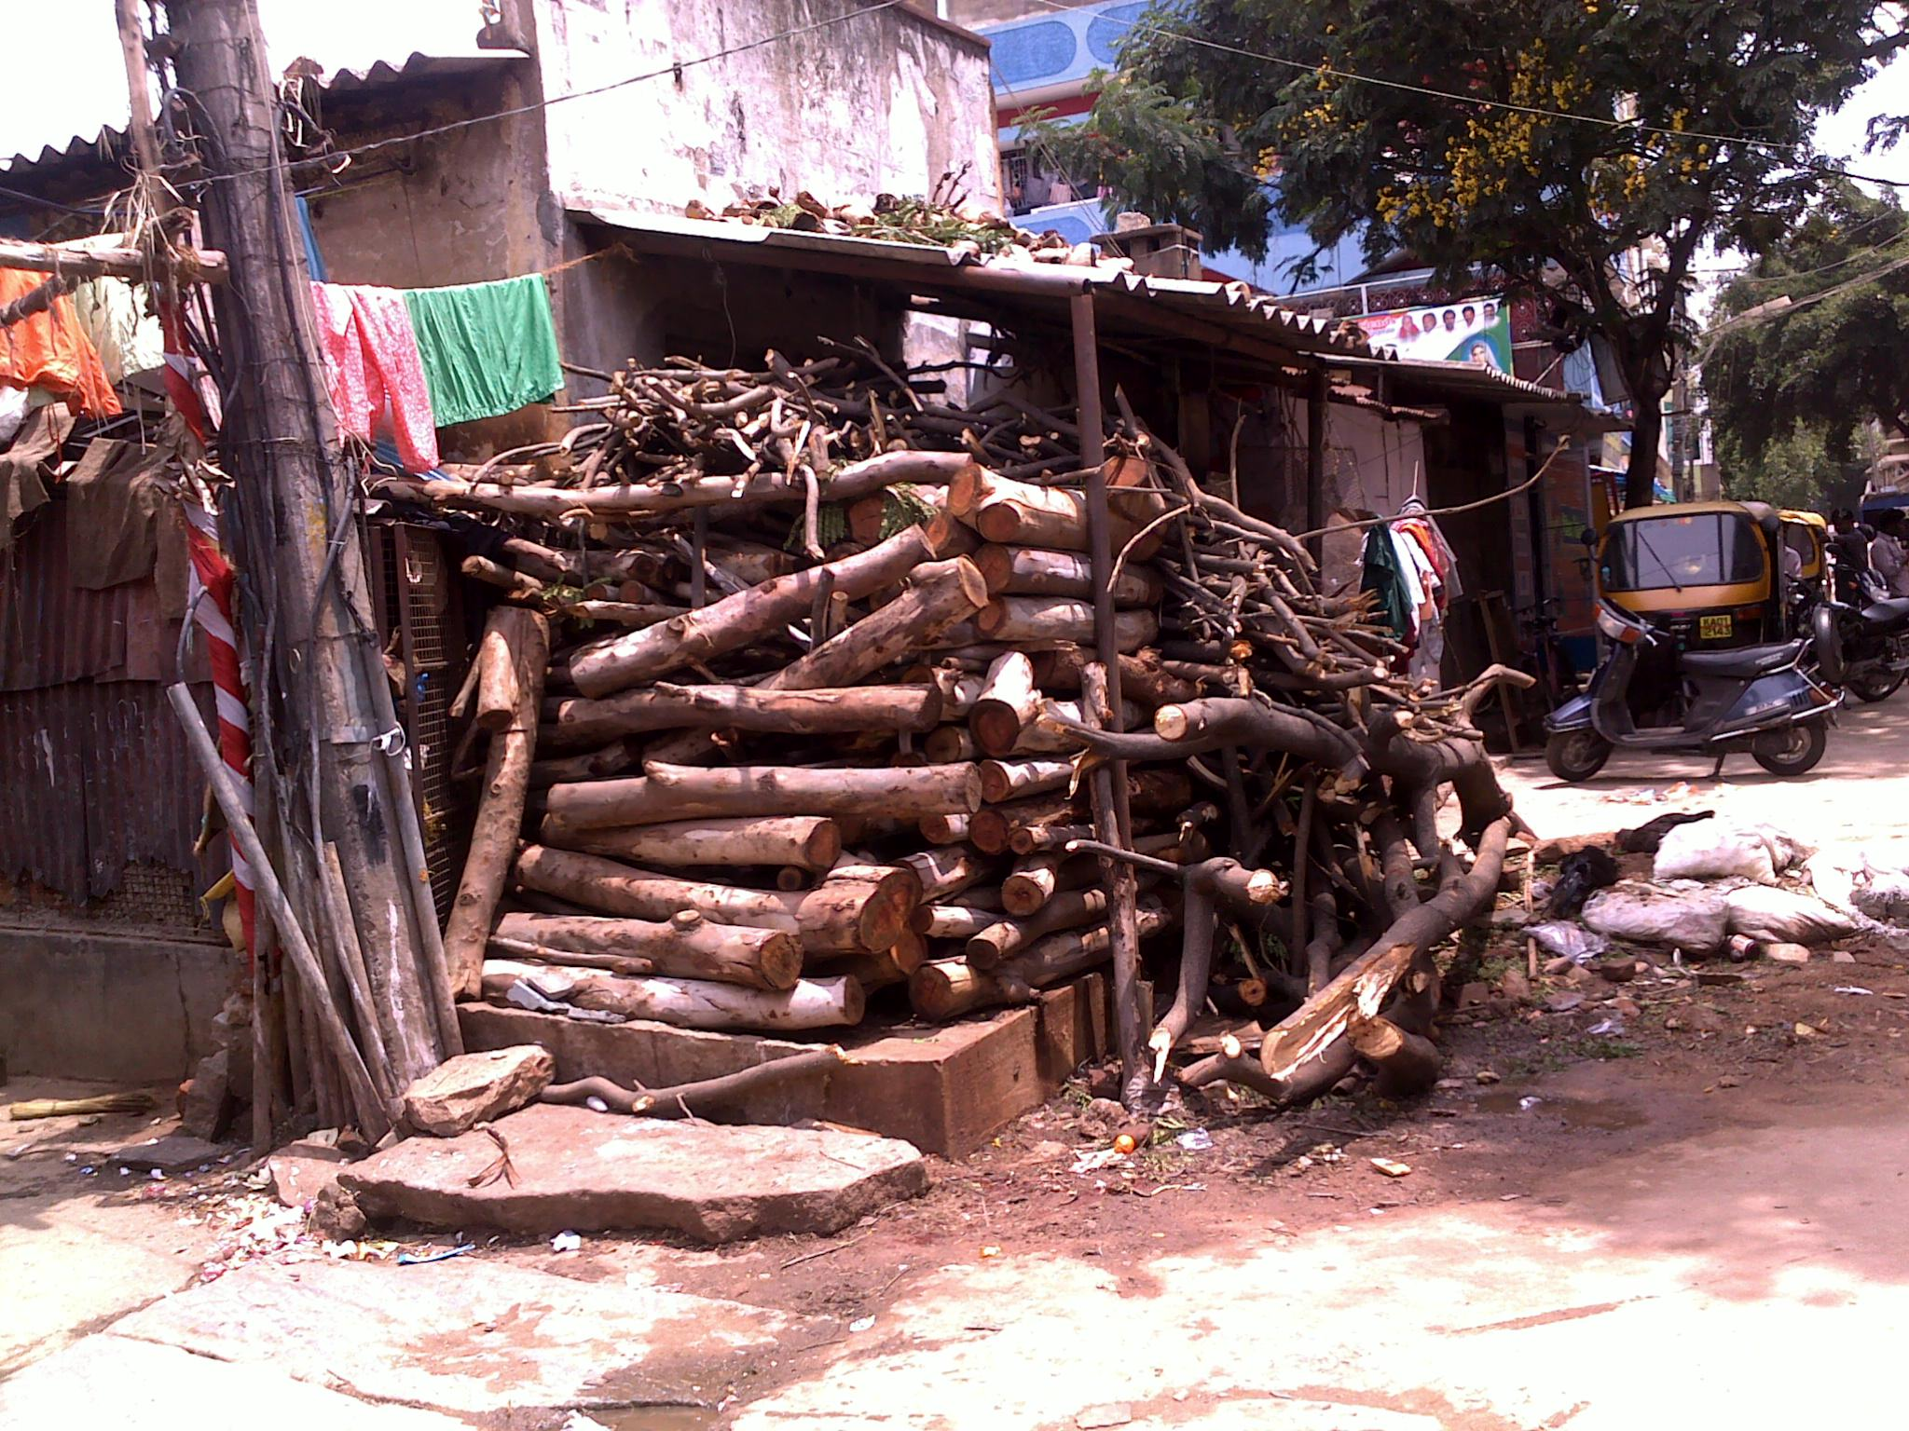

In EWS Quarters, where the respondents were used to a different kind of lifestyle in the past years, the usage of LPG was seen to be more widespread than in KS Garden and Parappana Agrahara, irrespective of the income of the respondents. Here too, only 13 respondents used LPG as the only fuel source for their cooking needs. 19 respondents of the total 54 interviewed, made use of LPG as a fuel source, of which, only 2 respondents used it in conjunction with kerosene and firewood.

The usage of the different fuel types, in the case where the respondents used a variety of fuels was of a conservationist type. Among the families who used LPG in association with kerosene and firewood, in all the three areas, it was observed that kerosene was used in the event of scarcity of the gas facility, while firewood was used to heat bath water. This measure of using firewood to heat bath water was seen to be a method of conservation of more valuable (in terms of cost) fuels like LPG and kerosene for meeting the family’s food demands for a longer period of time. The same pattern of usage was observed in the families, which made use of kerosene as a fuel in association with firewood and other biomass. Kerosene was used to secure the cooking demands of the family, while bath water was always heated using the firewood.

However, the system has its own set of issues. The supply of kerosene through the ration card is limited to 7 liters per family per month. Unscrupulous practices by the dealers mean that the family does not get even 5 liters per month of the resource. They are forced to procure the kerosene then, at exorbitant rates that tax the family’s already meager incomes. In order to deal with this issue, some families use the limited amount of kerosene provided initially, and then switch over to firewood or other biomass, to meet their cooking demands for the remainder of the month. The usage of firewood however, is hampered in the monsoon months, where setting an open fire is not a viable option. The families then rely upon the black kerosene market to fulfill their demands.

It was observed that in all the three areas, the use of fossil fuel and inefficient burning of natural resources was the most predominant. A choice that was made for the respondents either due to lack of resources or their nature of accommodation, but one which is indicted in the name of black carbon, and has far reaching consequences in the context of climate change and its effects.

Among the people we interviewed, LPG was not pre-dominant, and they cited reason of lack of funds, and space. The decision is however influenced by the fact that organic waste and other material is easily available. This is supplemented with firewood and Kerosene stoves.

TRANSPORT:
The main public transport is the bus service of the Bengaluru Metropolitan Transport Corporation (BMTC). Till recently these services predominantly served the main routes, with change-overs at key points like Majestic (Kempegowda Bus Stand), Shivaji Nagar, City Market etc. Thus cheap second hand two wheelers autorikshaws (three wheelers) became the preferred mode of transport. Most poor people took to walking to the feeder points or to two wheelers if their place of work was close enough.

Khader Sharief Garden is located between the busy thoroughfares of Double Road and Lal Bagh Road. Thus while no bus comes into the slum, there are a large number of buses available at the feeder points. The roads inside the slums are too narrow for the buses, but numerous autos are seen plying up to the periphery of the slum.

EWS Quarters is located opposite the Bangalore One Center feeder point at Koramangala, where there are a lot of buses. The slum is accessible to emergency services like ambulances, fire response services and other vehicles. A good collection of autos also ply in the bylanes.

The village of Parappana Agrahara, is however a few kilometers from the Hosa Road Junction which is the feeder point on the route to Electronics City. While buses to the feeder point are plenty, buses into the village ply erratically, almost every two hours or so. Private bus/Van services or autos are also very limited.

MODES OF TRANSPORT USED:
Mode of Transport daily |  | KS | EWS | PA
Walk (substantial) | 1 | 30 | 24 | 20 | 74
Bus | 7 | 18 | 12 | 14 | 44
Two wheeler | 8 | 3 | 7 | 5 | 15
Auto | 10 | 3 |  |  | 3
other |  |  |  | Car(driver) | 1
Total Incidences |  | 54 | 43 | 39 | 149
Total Responses |  | 47 | 45 | 40 | 132
out of |  | 55 | 54 | 45 | 154
Walk & Bus | 1 & 7 | 5 |  | 1 | 6
Walk & Auto | 1 & 10 | 2 |  |  | 2
Bus & Two wheeler | 7 & 8 | 1 | 3 |  | 4

Transport in Emergency |  | KS | EWS | PA
Walk |  | 21 | 18 | 17 | 56
Auto |  | 19 | 18 | 8 | 45
Ambulance |  |  | 2 | 1 | 3
Bus |  | 2 | 3 | 7 | 12
Two wheeler |  |  |  | 2 | 2
Car |  | 1 |  | 1 | 2
total incidences |  | 43 | 41 | 36 | 120
total responses |  | 41 | 42 | 29 | 112
out of |  | 55 | 54 | 45 | 154
Walk/Auto |  | 2 |  | 2 | 4
Walk/Bus |  |  |  | 2 | 2
Auto/Two wheeler |  |  |  | 1 | 1
Auto/Bus |  |  |  | 2 | 2

The most preferred mode of transport in KS Garden was walking to the place of work, followed by the usage of the public bus systems. Within Parappana Agrahara, which is a place constrained by the access to public transport services, the respondents either tended to walk or use their private modes of transportation. In EWS Quarters, interestingly, it was observed that 40 out of the total of 54 respondents interviewed tended to walk to their place of work. The usage of privately owned vehicles was also not restricted to the people with the highest income. In all the three areas, among the people who commuted daily using private means, a privately owned two wheeler was the most common. There was no individual among the interviewed who owned a 4-wheeler.

This graph tries to draw a relation between the distance travelled to work and the mode of transportation preferred by the respondents. People travelling longer distances tend to rely more on the public transportation system ranked 3, the people who travelled shorter distances walked to their destination for the most part. People travel medium distance for regular jobs or small businesses, prefer using rented autorickshaw or their own two wheeler, generally the very cheap second-hand ones, which may be inefficient from the fuel consumption point of view but given the short distances they have to travel, there is no incentive for them to acquire more efficient vehicles or spend money on maintenance.

It may be noted that in Parappana Agrahara, a vast majority of the people interviewed had only short distances to traverse, and therefore preferred walking or cycling as an alternative to the erratic bus service within the area. In EWS Quarters also, a large majority of respondent families had shorter distances to cover and as such the preferred mode of transport was by walk or the bus. In this slum, however, the distance travelled by the respondent dictates the ownership of a vehicle as seen from the graph. This pattern differs from what was observed in the other areas surveyed as in both KS Garden and Parappana Agrahara, the ownership of a vehicle was determined by their income.

In this context of climate change, this pattern observed in EWS Quarters, may be seen as a resilience building strategy against the current consumerist approach to ownership of vehicles. Here, the need to traverse a large distance engenders a need to improve upon the mode of transport and while the distance remains shorter, other means of transport are seen to be preferred. Can this be translated into a policy framework, as a means to conserve fossil fuel and to ease the pressure on Bengaluru’s already chock full traffic scenario?

http://www.bwssb.org/sewerage_system.html last accessed on 2 June 2011, at 3:05pm, IST
BWSSB’s new plans for Water Conservation; The New Indian Express,Bangalore Edition, dated 23 March 2011.
http://www.bwssb.org/help_faq.html last accessed on July1, 2011 at 11:13am, IST
http://www.schools.indiawaterportal.org/sites/schools.indiawaterportal.org/files/Bangalore_Water_Supply_Res ources.pdf

