V. Learnings from study

The aim of the study was not so much to determine the extent but to understand the nature of vulnerability. We were not able to separate the vulnerability to climate change from the other intertwining vulnerabilities. This meant that we could only explore the interlocking issues and learn about areas of adaptation that go beyond climate change.

The predominant vulnerability of people living in the slums under study is water logging and flooding. This has direct impacts on the general health particularly of children who are prone to allergies resulting in colds, asthma etc. The other impact is on vector borne diseases, particularly Chikungunya. In all the areas surveyed, the incidence of such diseases particularly during epidemics is far higher than for the general population.

Beyond vulnerability relating to elevation and natural drainage of the slum, the exact extent of vulnerability correlates primarily to the specific history of intervention by political events or NGO intervention on issues of tenure, and specific problems like water, amenities like toilets etc. The other important indicator is the nature of housing. While it is generally true that income and status has a lot to do with the kind of houses people possess and the kind of drainage they use, the more significant operand has been the development programme, and interaction with the slum development/regulating authority.

Though people generally build their own dwellings, their vulnerability stems from the fact that they cannot choose a good location, and have to make do with what is there to be occupied. The newer entrants would go by the rent or unofficial payments they can afford. Once settled, the incremental nature of improvement of habitat and housing is a creative function, where people use whatever resources they can muster in their environment. The extensive use of plastic sheets, gunny sacks, used flex, or buckets, plates to ward off the water, and then resorting to physically bailing out water, raising barricades of one to two feet height etc is a testament to the resilience, or more correctly struggle of people against the elements. That this is likely to get worse in climate change is not in their radar, but they have perceived a change in the pattern of rains.

Most vulnerable are those who have mud flooring, this combined with poor drainage of grey water in the neighbourhood, makes any kind of perturbation extremely intolerable. They are the poorest and cannot afford to fall ill.

Women are most affected by and the burden of recovering from water logging – namely swabbing, bailing out water, dealing with overflowing *mori*  mainly falls on them. They are also affected by contamination of water. Overall most women we interviewed said that the situation with the water has been improving. This is mainly due to the fact that they do not have to fetch water from the distances that they used to, or that arrangements have been made, sometimes locally, to bring the water points closer home. To that extent, the BWSSB has been making changes, bringing piped river water, or digging more borewells with local storage tanks. The maintenance of these are very precarious, and the women complain of foul smelling water, and even worms in the supply.

In the newer areas, namely in the peri-urban fringes, women perceive a loss of traditional livelihood options like goat tending, agriculture, kitchen gardening, as their habitat gets increasingly urbanized and polluted. Extremes of climate events would perhaps make this worse.

A similar learning arises from the paucity of firewood. While subsidized kerosene is provided at ration shops, these are not sufficient, and its supply entails a lot of leakages. In our study we found that people make up that shortfall by using firewood stoves, where they use all kinds of waste from the environment, many of the substances quite toxic, when burnt. Most people do not use LPG as their spaces/huts are not designed to house a stove attached to a cylinder. Perhaps the one-piece stoves, distributed free would take care of their special and safety concerns.

In the area of health impacts, we looked at practices. While people do tend to make offerings and prayers to recover from illnesses, these actions seem to be more out of “abundant caution”, as they go in for different forms of treatment. First preference would be different types of home remedies like *kashayams.* The second is buying medicines off the counter. The doctor is not the preferred course of action, as they are not proximate and involve travel and medical costs. Most helpful adaptation would therefore be more information on oncoming epidemics, increasing instances of viral attacks, so that people can appreciate the nature of the symptoms. And of course, a low cost, friendly Primary Health Centre would be most welcome and effective.

An important vulnerability arises from security of housing tenure. We have seen higher mobility in EWS quarters, where people had legal titles and identities. As soon as people become better off, they tend to shift out to a better location. Thus the poorer persons tend to stay on and live with the mud floorings, and leaky roofs, and do patch-work with whatever resources that they have. So even in areas where there is high mobility, those who are left behind are increasingly those who are poorer and therefore concentration of vulnerability is both in terms of conditions as well as income.

In Parapanna Agrahara, the people are more rooted in the area, and they have traditional occupancy rights, and traditional forms of livelihood. Here most floors were cemented, and asbestos roofing, save one or two of the poorest who have to do with mud floor and thatched roofs.

In Khader Sharif Garden, which was actually occupation of private land a long time ago, most floors would be cement and roofs tiled or of asbestos. Here there is a little mobility and excessive crowding. Thinking of mobility and crowding, many of the fresh migrants into the city, work in familial network, and therefore crowding into existing spaces in the old slum areas.

As migration to cities is bound to increase, partly due to climate change, capacities would be stretched, and the poorer incoming lot would get into spaces like the old run-down sheds in EWS. Run down places never die, they find new occupants! But on a more serious note, one of the main learnings of this study has been what we have not been able to study – namely the newer migrant, and their initiation into the worst and most vulnerable of locations.

Most issues like toilets, good drainage are best sorted out at the community level, at least for maintenance. The example of KS Garden where the three persons required to maintain the facility are paid by the contributions, and supervised by representatives of the community, rather than as is the case of EWS where the staff of the community toilets are seen as employees of the corporation.

Water and Electricity become the indicators of progress, small amounts of which are greeted gratefully. Almost all would use electricity for basic lighting. Though there are a few CFL bulbs, CDMs giving free CFLs would be ideally welcome.

Almost every home will have a TV, and would take pride in owning one. The Fan and Mixie are a necessity, but both of which have come into prominence as hand me downs or poor second hand purchases.

Most of these appliances are energy inefficient, but they are well worth it as they provide immense value to a beleaguered life. Electrical wiring also is temporary. Electrical efficiencies given the low rate of consumption, is not an economic option for the household point of view. Many people make do with connections from neighbours and loose wiring, and inefficient appliances. Perhaps the total electricity saved by proper regulated supply, good wirings and more efficient appliances would go a long way to pay for the material itself. Perhaps a potential pro-poor CDM!

The other issue is transport: wherever public transport is not convenient, people tend to use old two wheelers or hired autorickshaws for medium distances especially. Since it is used for essential travel only, the higher per-trip costs, far out-weigh the disadvantage of not being able to put the upfront money required to have a good efficient vehicle.

To us on the outside therefore there is a close link between urban systems of water, housing, sanitation, energy, transport, health and vulnerability to climate change. While people will do what they can at their level to cope with perturbations, there is an expectation of developments at the major infrastructure level. When we visited EWS quarters during the monsoons much after we did the survey, we found that the authorities had constructed many new sheds to replace those which were in a pathetic condition. Side by side individual people, who did what they could. Many cemented their flooring. They of course did not have the resources to redo the foundation, or make byways for underground flow of water so as not to harm their foundations.

To conclude, housing practices, plan & design, and utilities are the main parameters which affect vulnerability. The absolute poor would have no means to do even the bare minimum. And what the little better off can do would hardly be sufficient to adapt even to pre- climate change situations. Thus climate change would call for more concerted and overarching integrated action, by a range of actors, particularly state, and NGOs.

The New sheds in EWS quarters

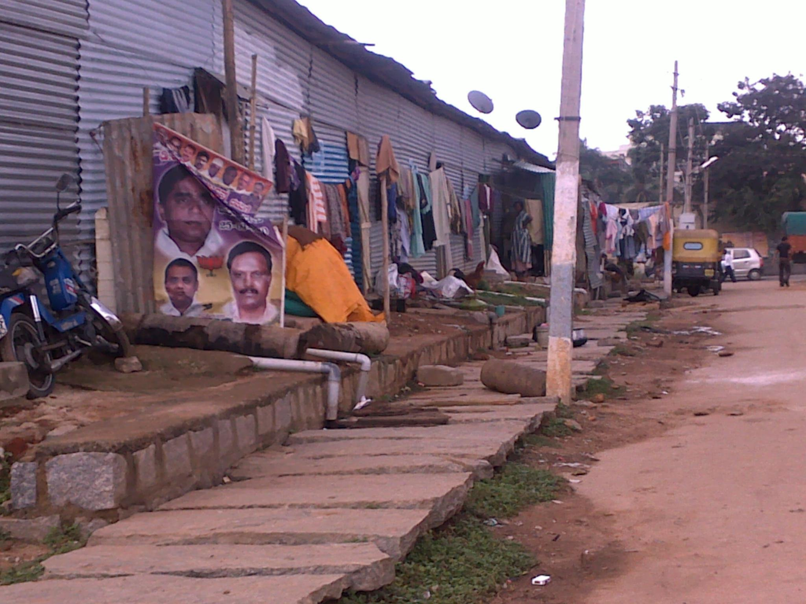

While proactive adaptation responses must attend to the needs of the poorest, any real resilience to impacts of climate change can only take place with development of employment, livelihood and habitat. Poor urban people highlight employment, assets and savings, and income as the key determinants of their well-being. This is heavily related to the security and predictability of income, as well as to the security of assets (e.g. tenure as opposed to ownership).

In terms of livelihood, the most buoyant careers in these three slums is service work ranging from municipal or public goods services, transports, plumbing, masonry, carpentry etc. For Destitute women and single women parents too, domestic work and that too part time, is a lifeline. Being unorganized, and dispersed, services is not evenly accessed, or given. The example of Shramik organizing a cooperative of such workers, and ending up being a pro-active habitat player, indicates the benefits of a cooperative approach. In places like EWS, unofficial extensions of water lines close to the homes of the women have been enabled by such cooperative action.