
YUVA DRISHTI – III 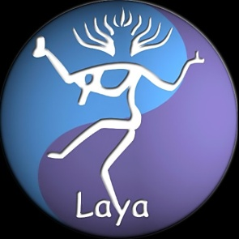
The THIRD EDITION of the youth conclave ‘YUVA DRISHTI’ organised by the Indian Network for Ethics & Climate Change is scheduled to be held at SEIMILIGUDA, ORISSA from Apr 10-12, 2012.

The main objective of Yuva Drishti is to include the youth in the mainstream climate change debate in India. Yuva Drishti is a conclave for and by the youth to debate and discuss our perspectives and hope for a sustainable future.

Added to this, an exposure visit to see the practical side of Decentralized Renewable Energy Models in a functioning environment at the foot hills of remote Adivasi regions of Orissa and meeting with some of the communities living there and the ways in which they are coping with issues related to climate change is also part of the program.

Please note that all costs towards transportation, lodging and boarding would be borne by the organisers.

For more details about the program & how to participate, please contact:
Ms Ajita Tiwari
Facilitator
Indian Network for Ethics & Climate Change
Email: inecc.mumbai@gmail.com
Mob:+91 96199 22286
Web: www.inecc.net

